AWS MINI PROJECT

VEERA REDDY INAKOLLU

LAB-1 ---> IAM HANDS-ON

* Setup the MFA for root user
  + Choose device name

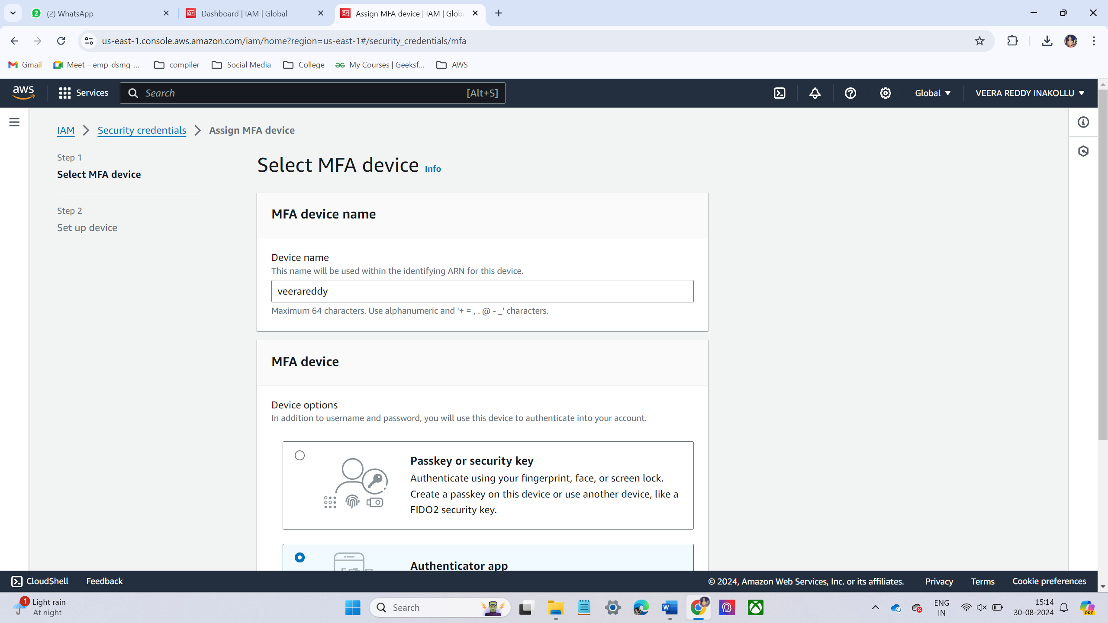

* + Select the device name. I have chosen Authenticator App. 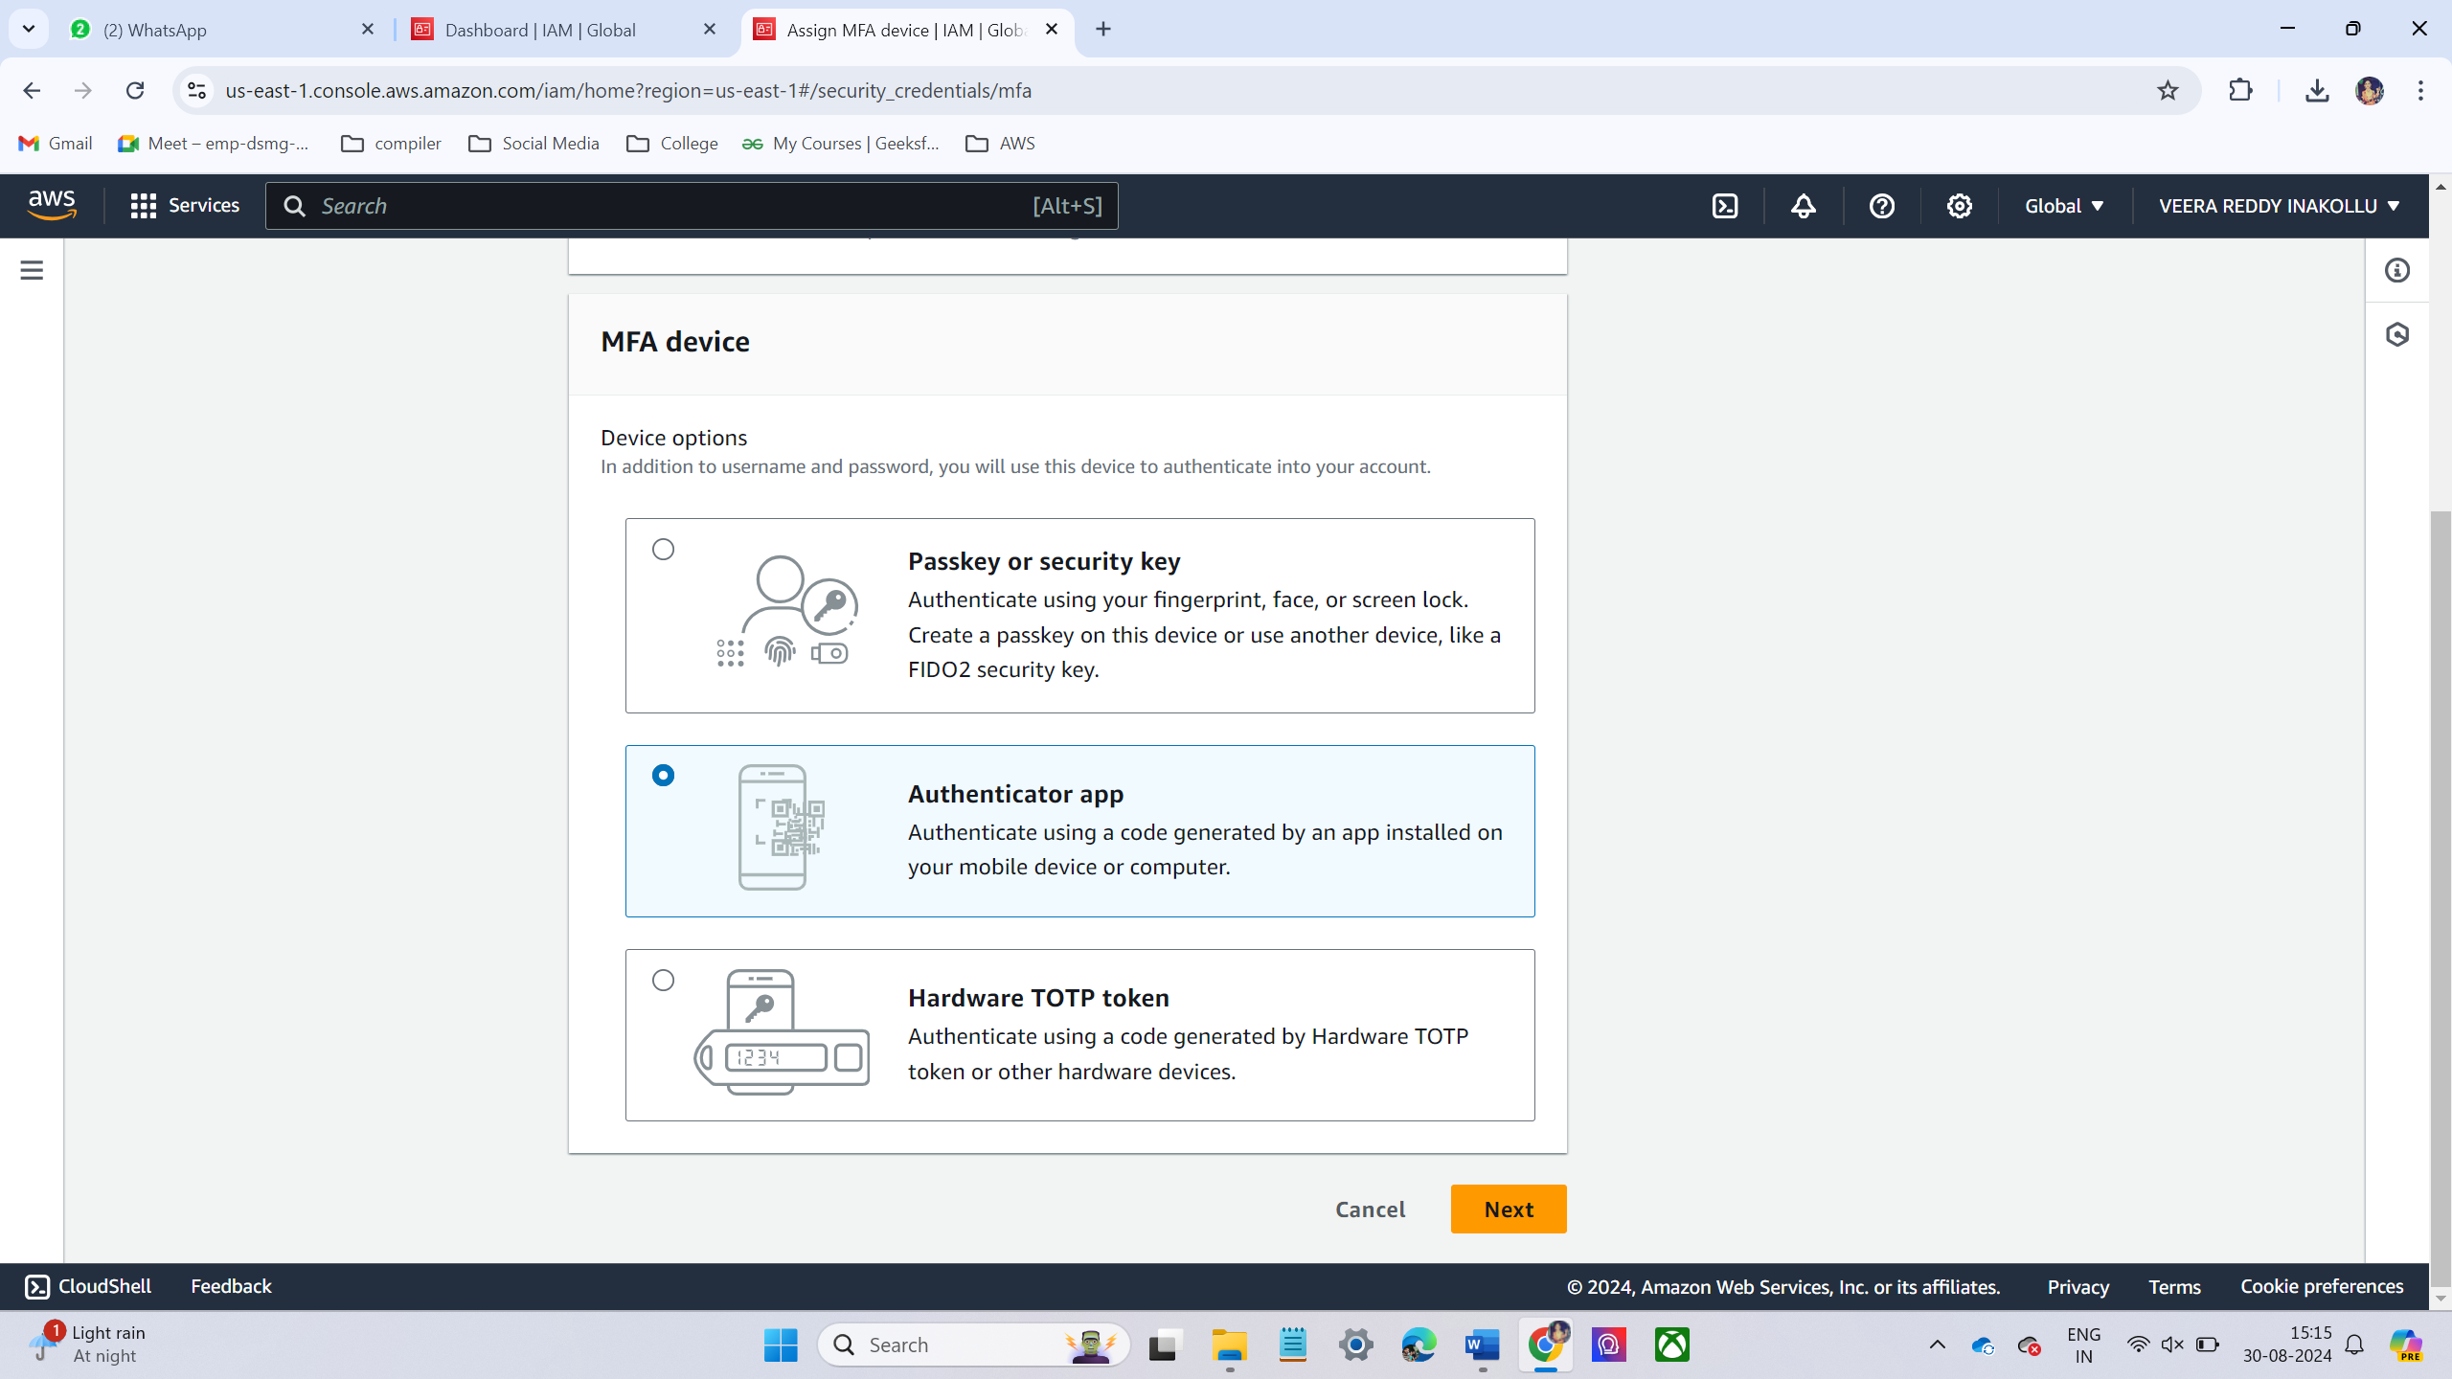
  + Then scan the QR code
  + Then it will show a code and then enter the code in 1st code and after 30sec it will show another code then enter 2nd code.
  + And then click Add MFA.

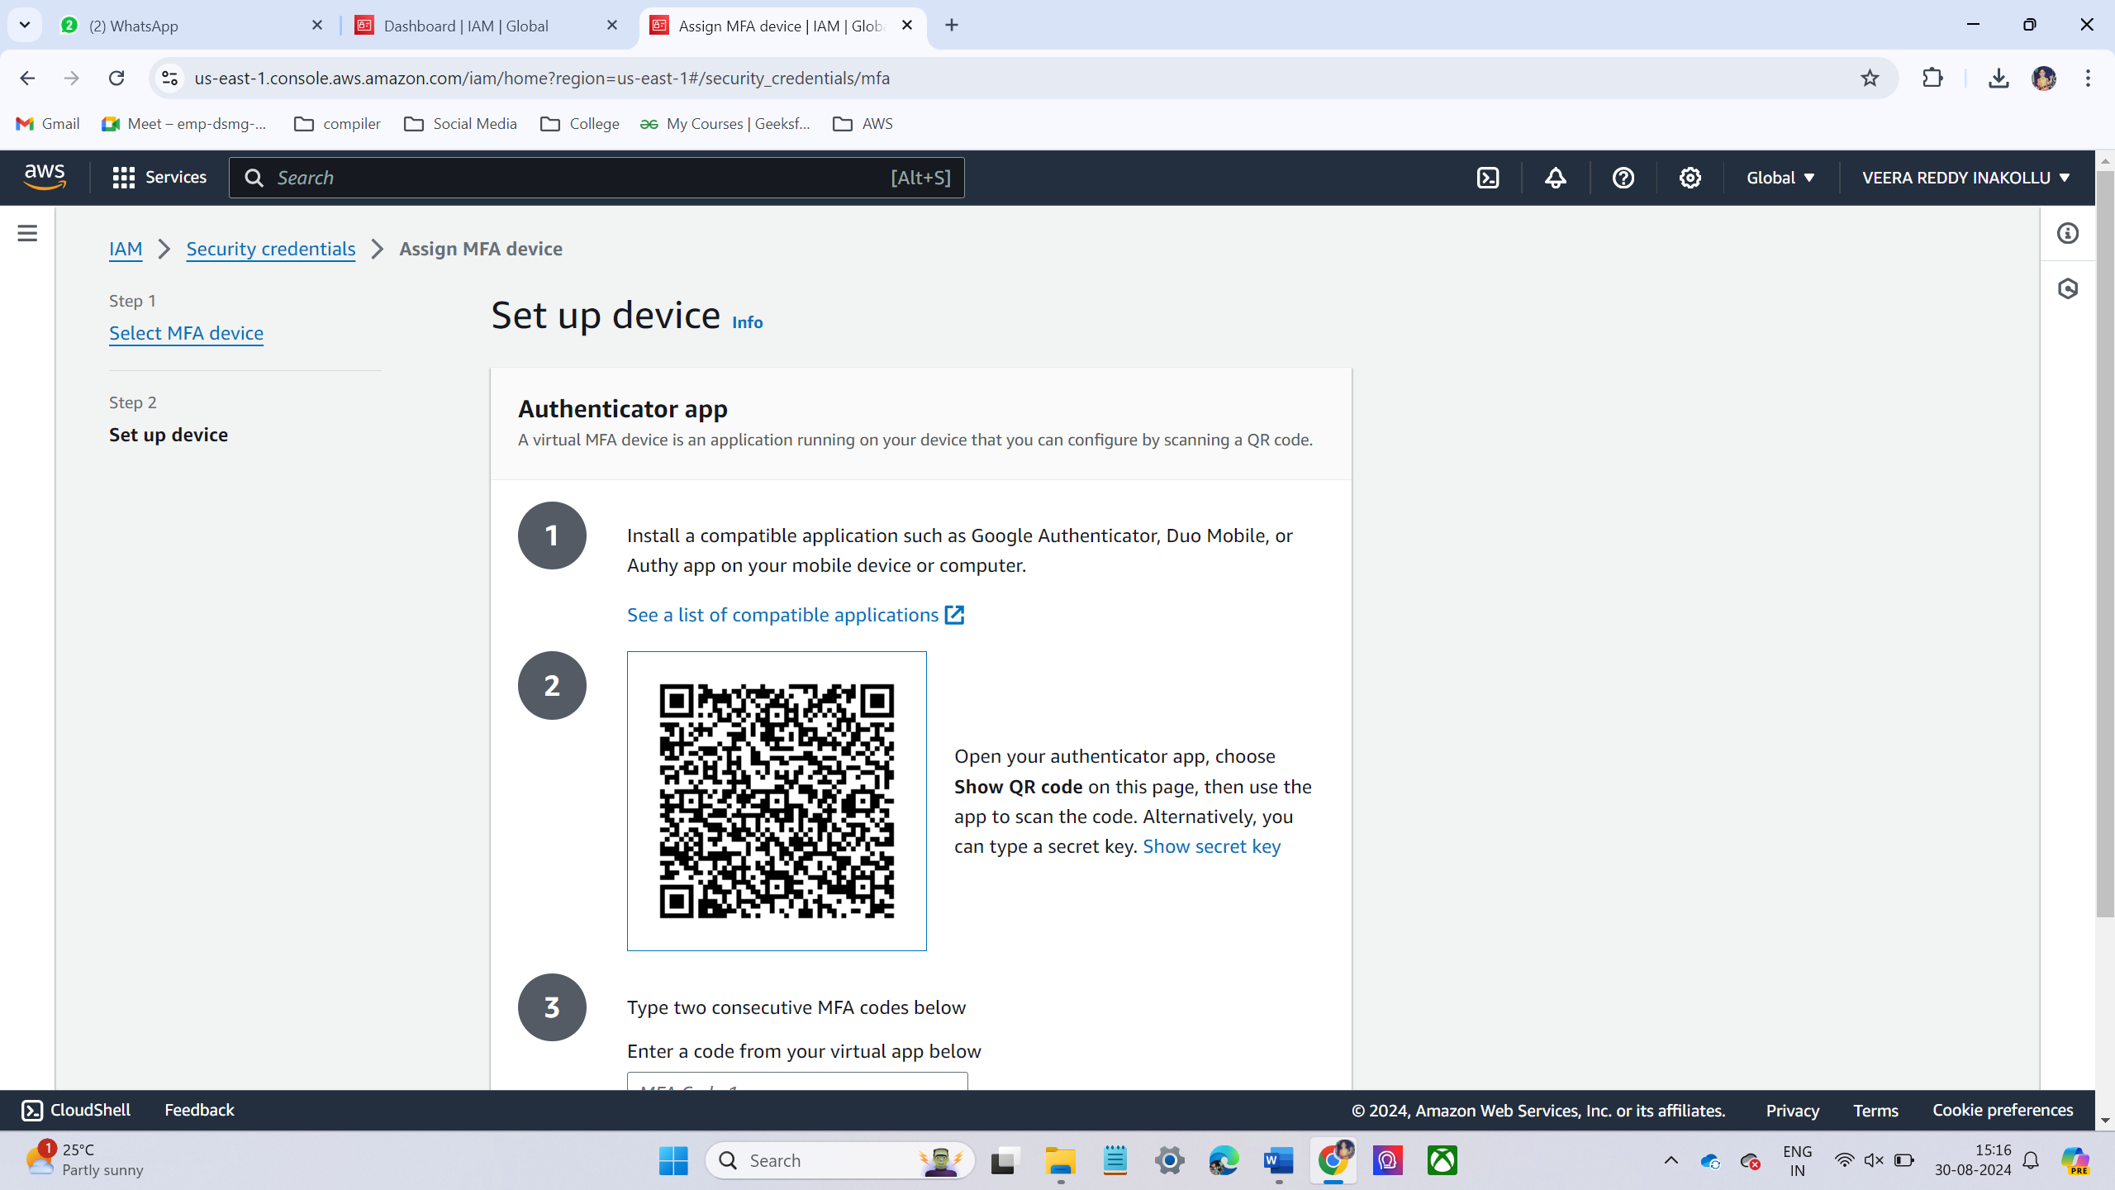

* + I have successfully created the MFA for root user.

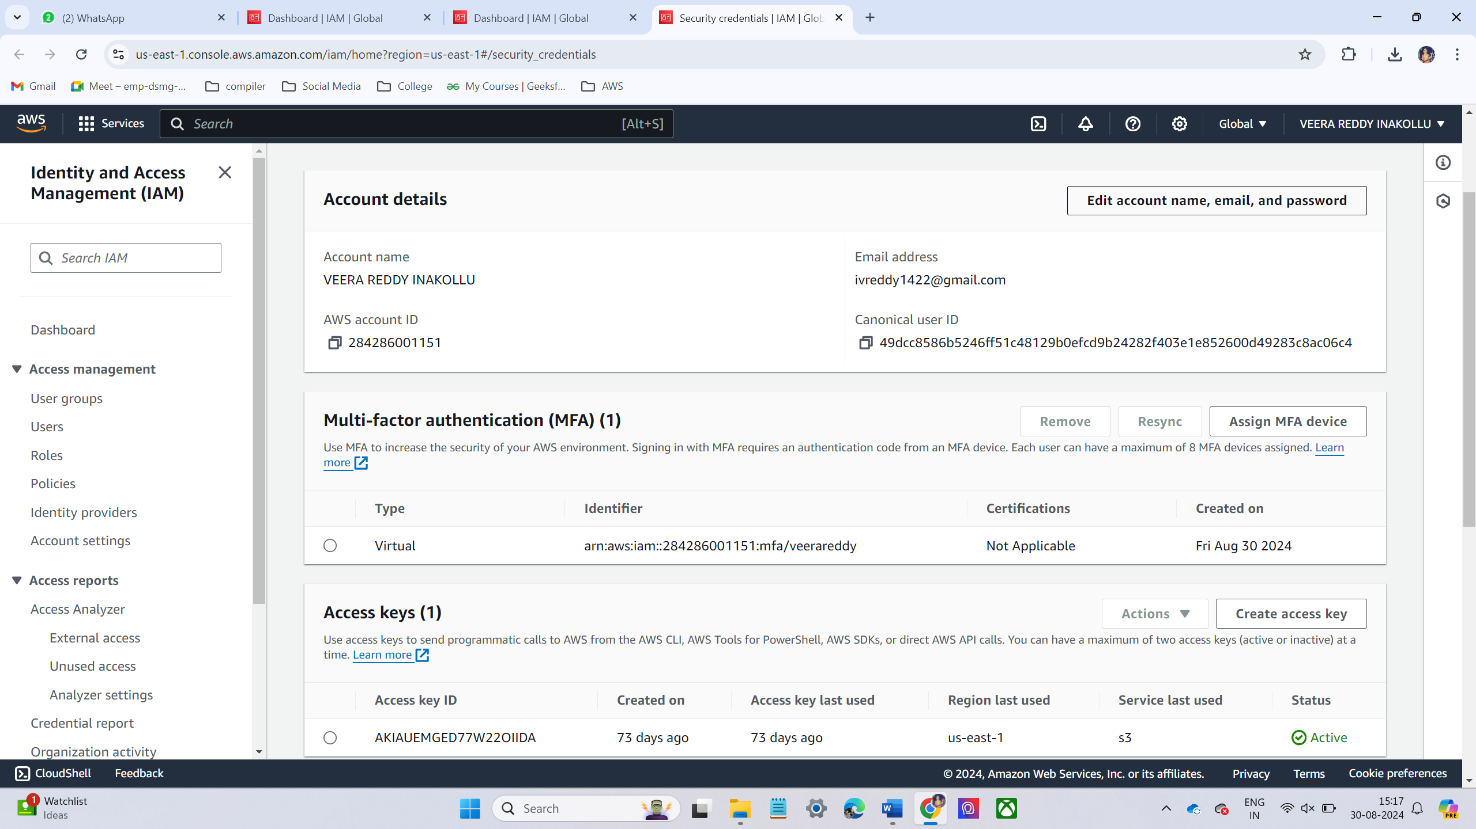

* Steps to create IAM user with console access.
  + Sign in to AWS account.
  + Navigate to IAM Service.

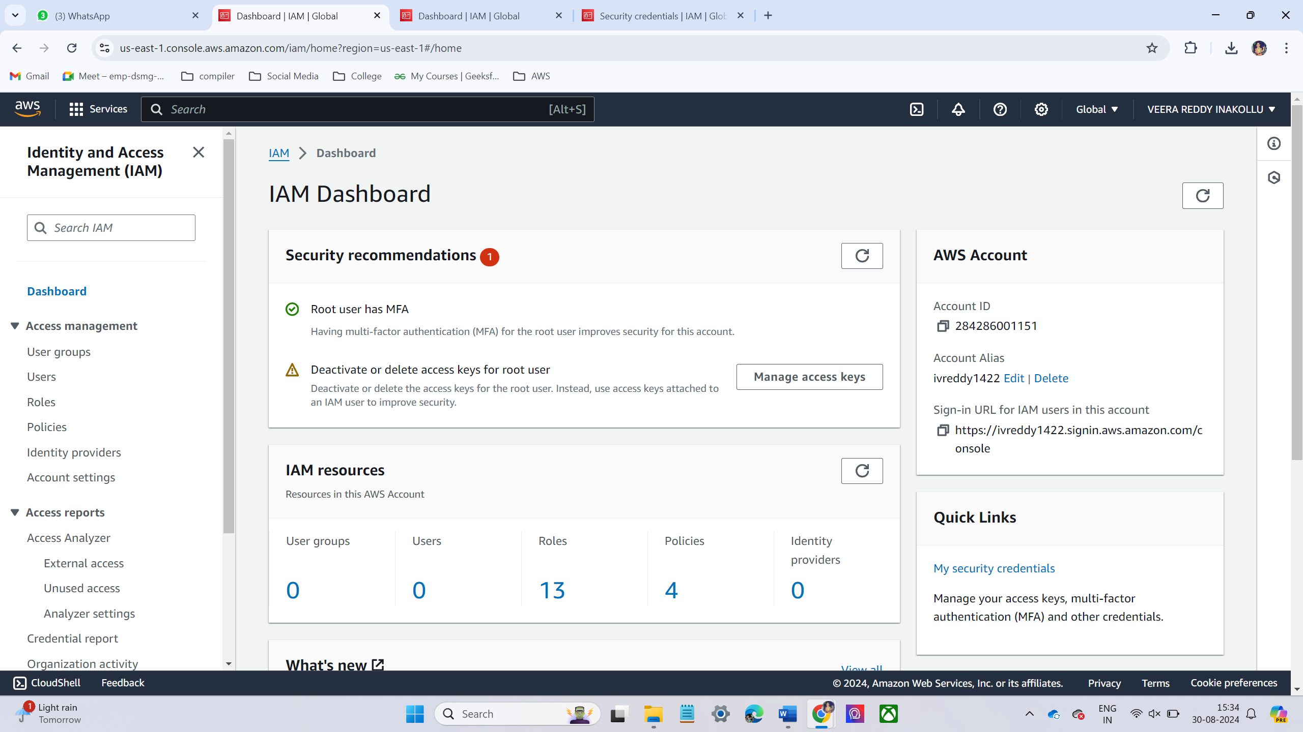

* + On IAM service on the left hand menu, select user and click Add user.
  + Specify the user details like username and access type.

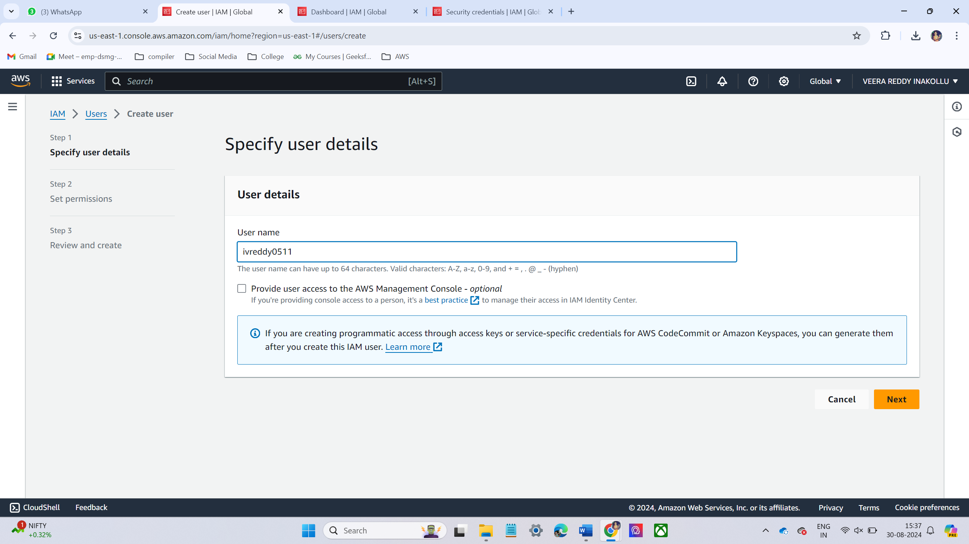

* + Attache policies
  + I have chosen only EC2 full access permissions and then click next then create.

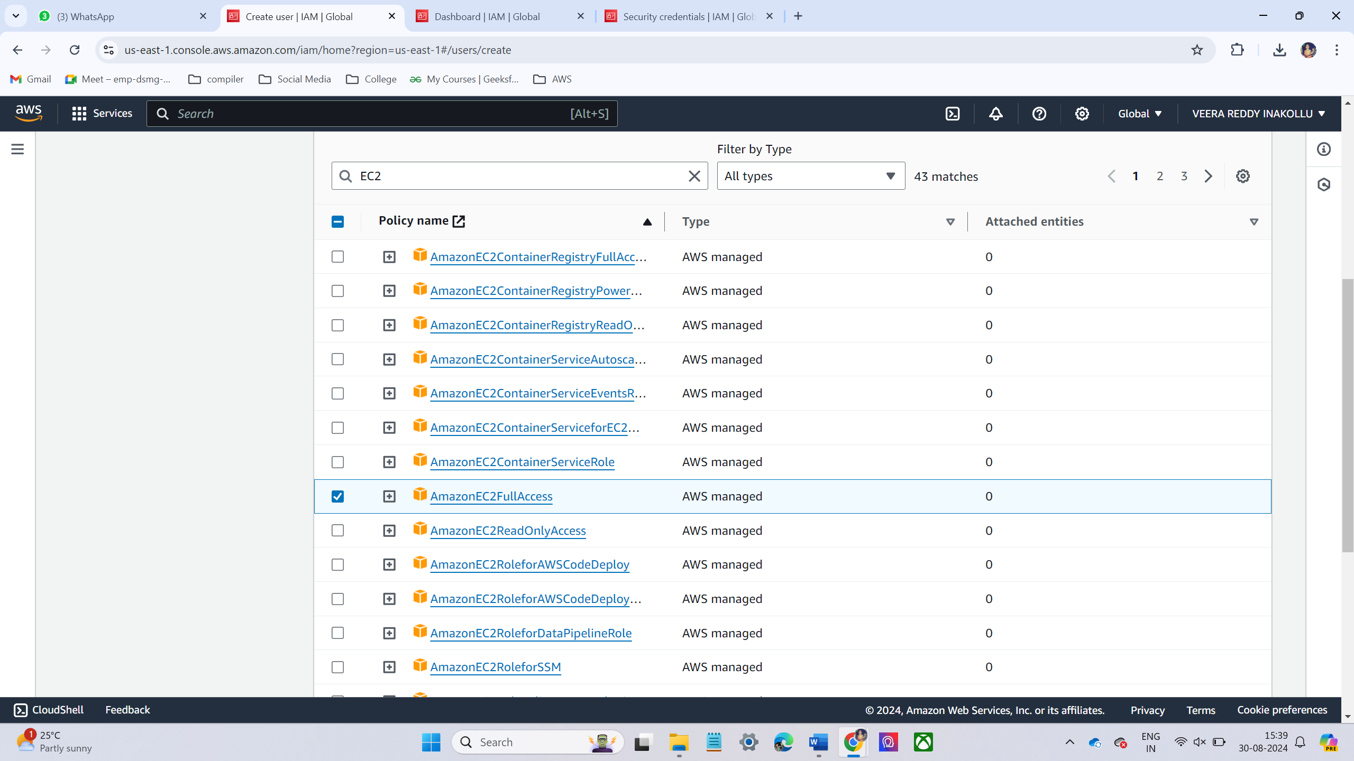

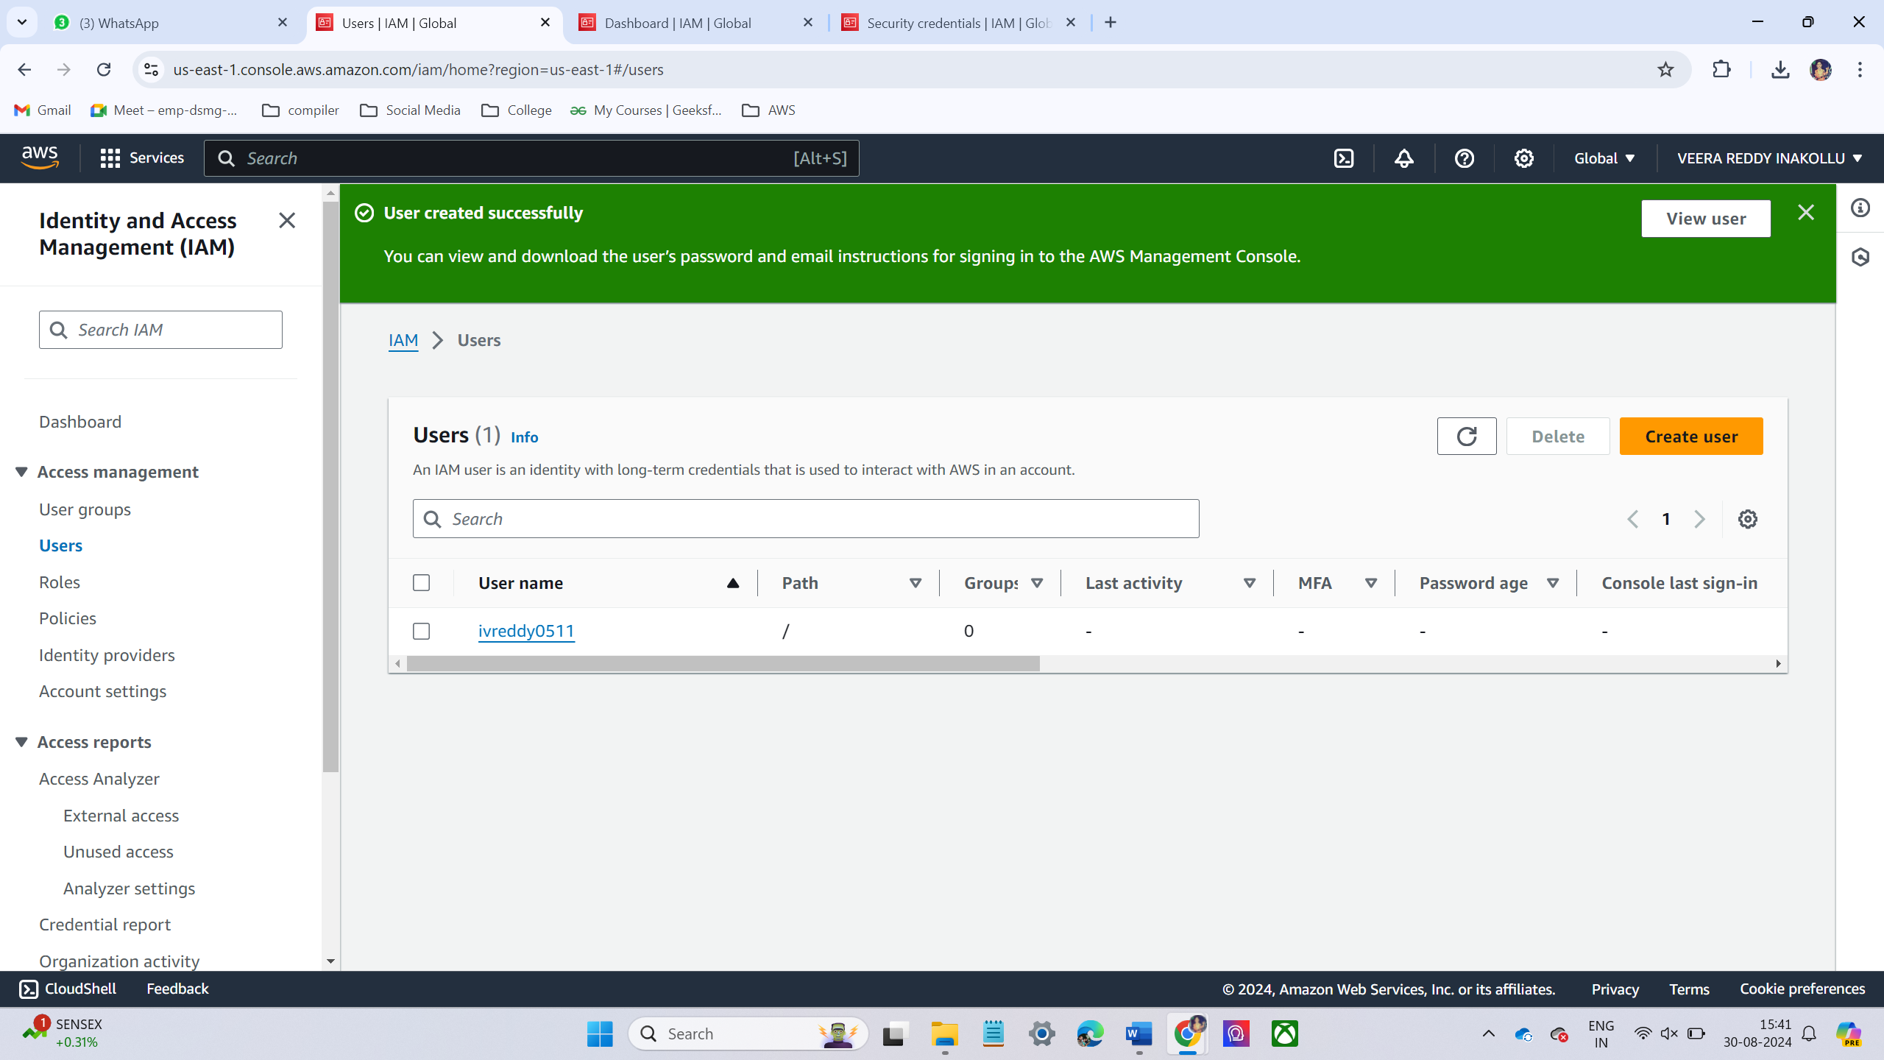

* Login into IAM user account.

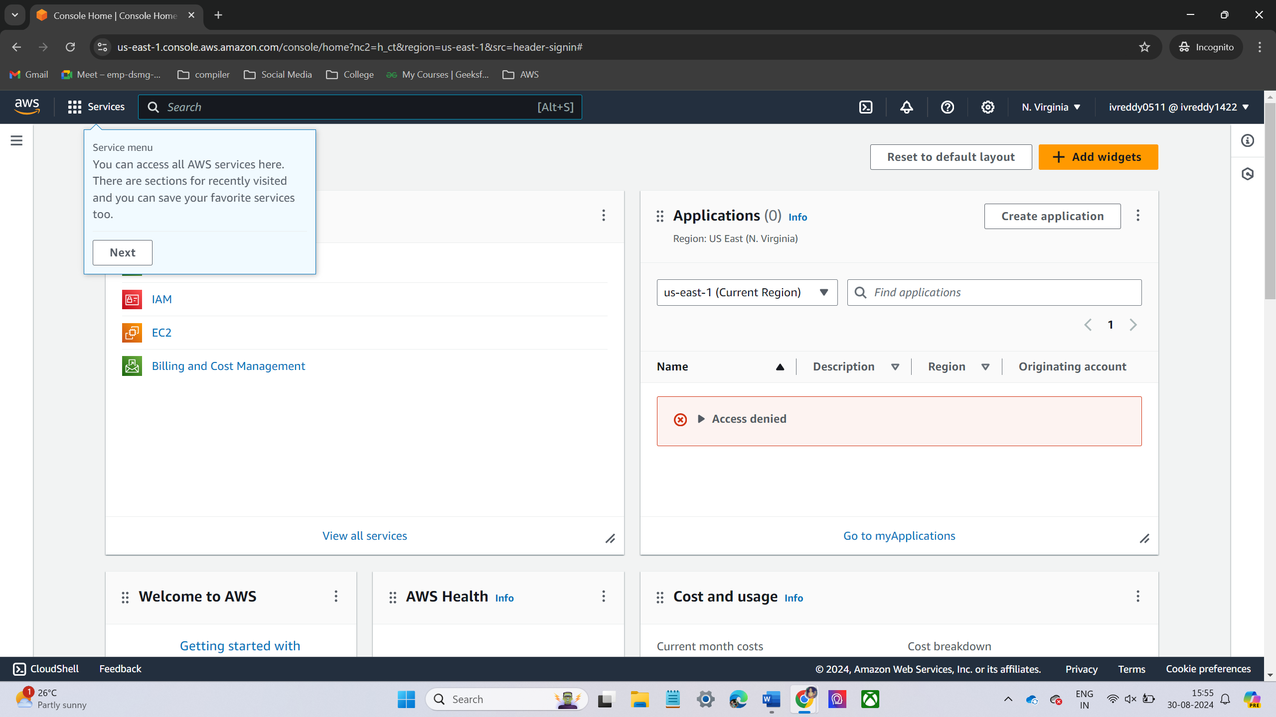

* Create S3 bucket in IAM Account.

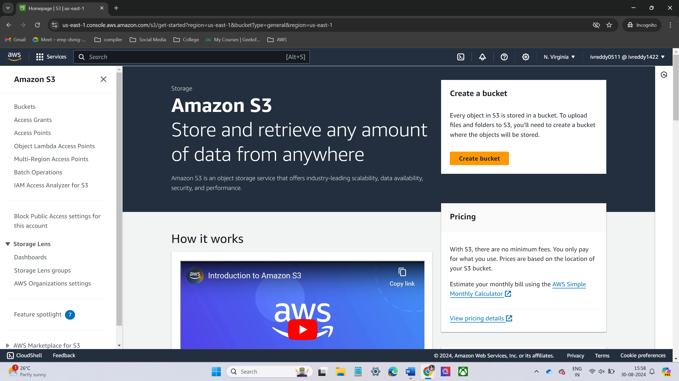

* Whenever I try to create bucket its show an error.
* Its shows an error like CreateBucket permission is required. Because when I am created the I am user i have given only ec2 permissions.

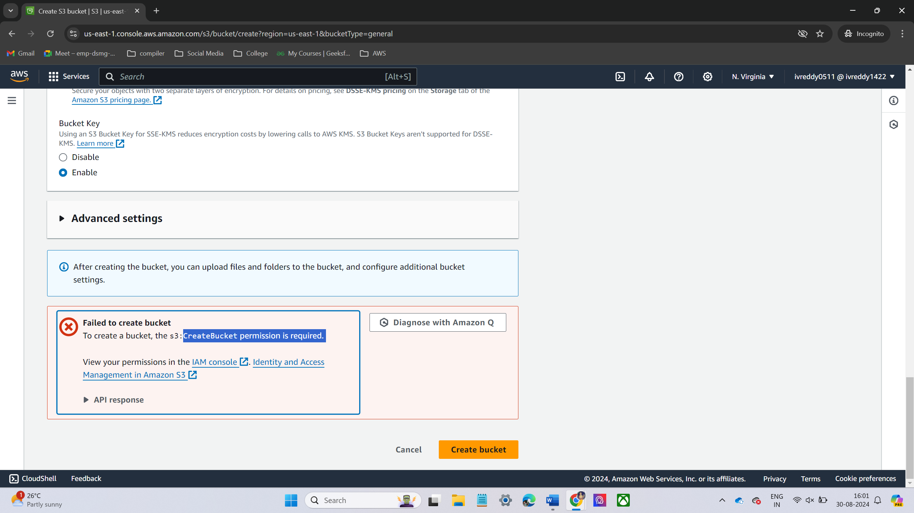

* Now I am giving full permissions to the IAM user

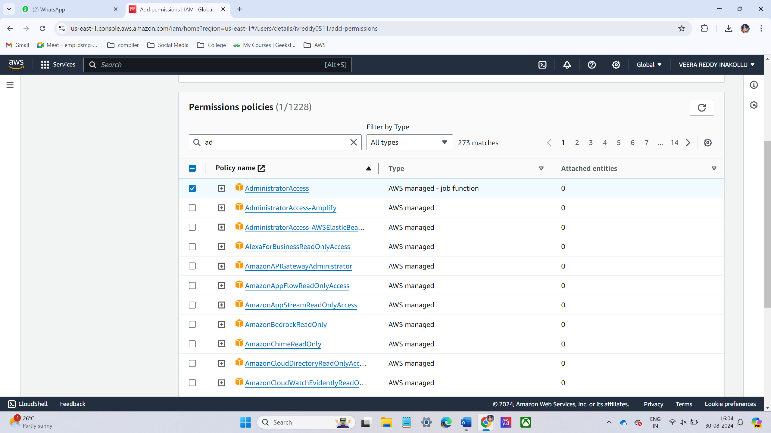

* Now I am creating S3 bucket after given the administrator access.
* after given the administrator access the S3 bucket is successfully created

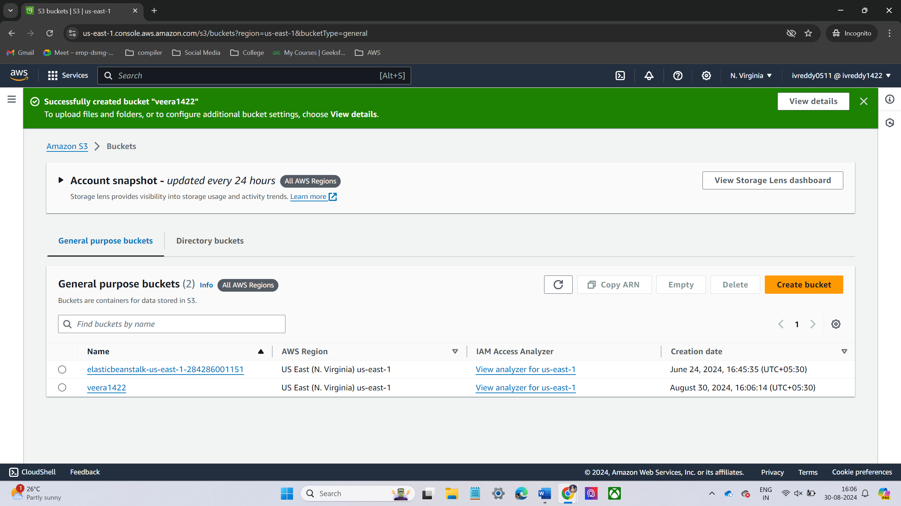

LAB – 2 -> Billing Alarm

* Go to the Billing and cost management home.

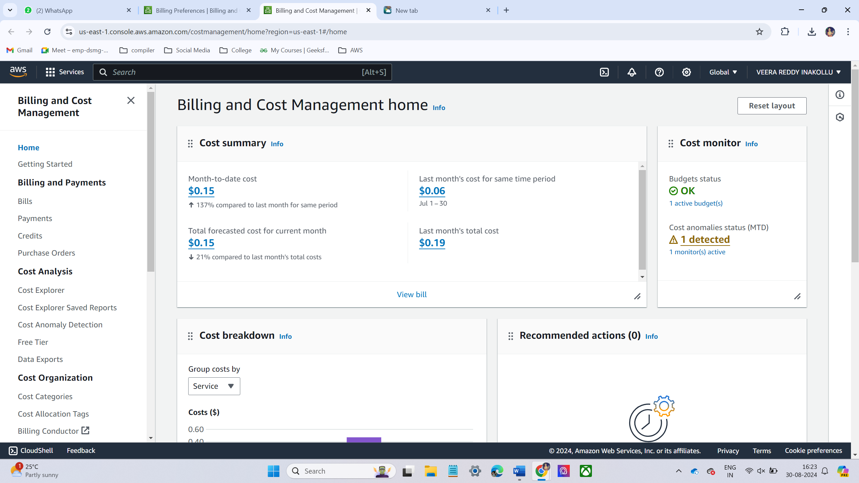

* On the left-hand side, under **Billing preferences**, enable the checkbox next to **Receive Billing Alerts**.

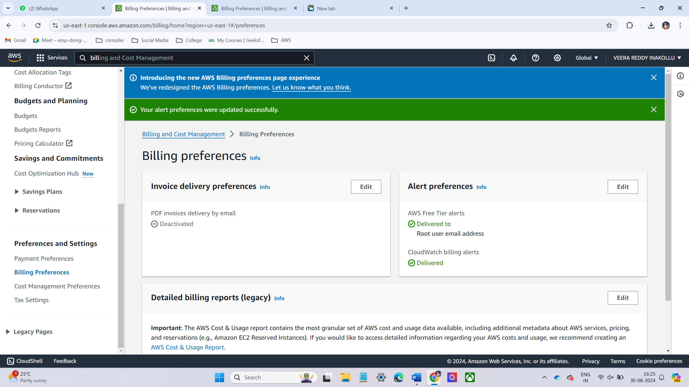

* Then go to cloud watch and click alarms

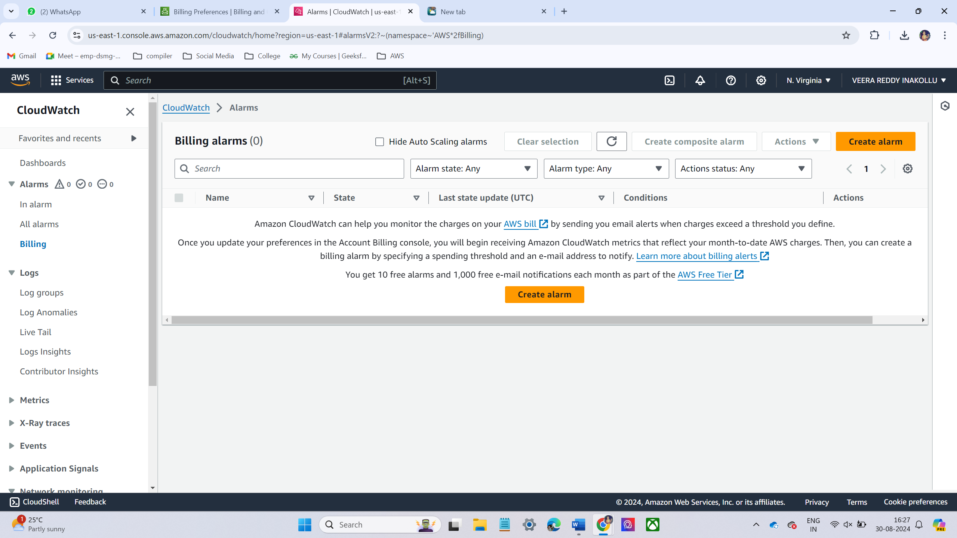

* Under **Create Alarm**, click **Select metric**.
* In the new window, click **Billing** from the list.
* Select **Total Estimated Charge**. This tracks the total estimated charges for your account.

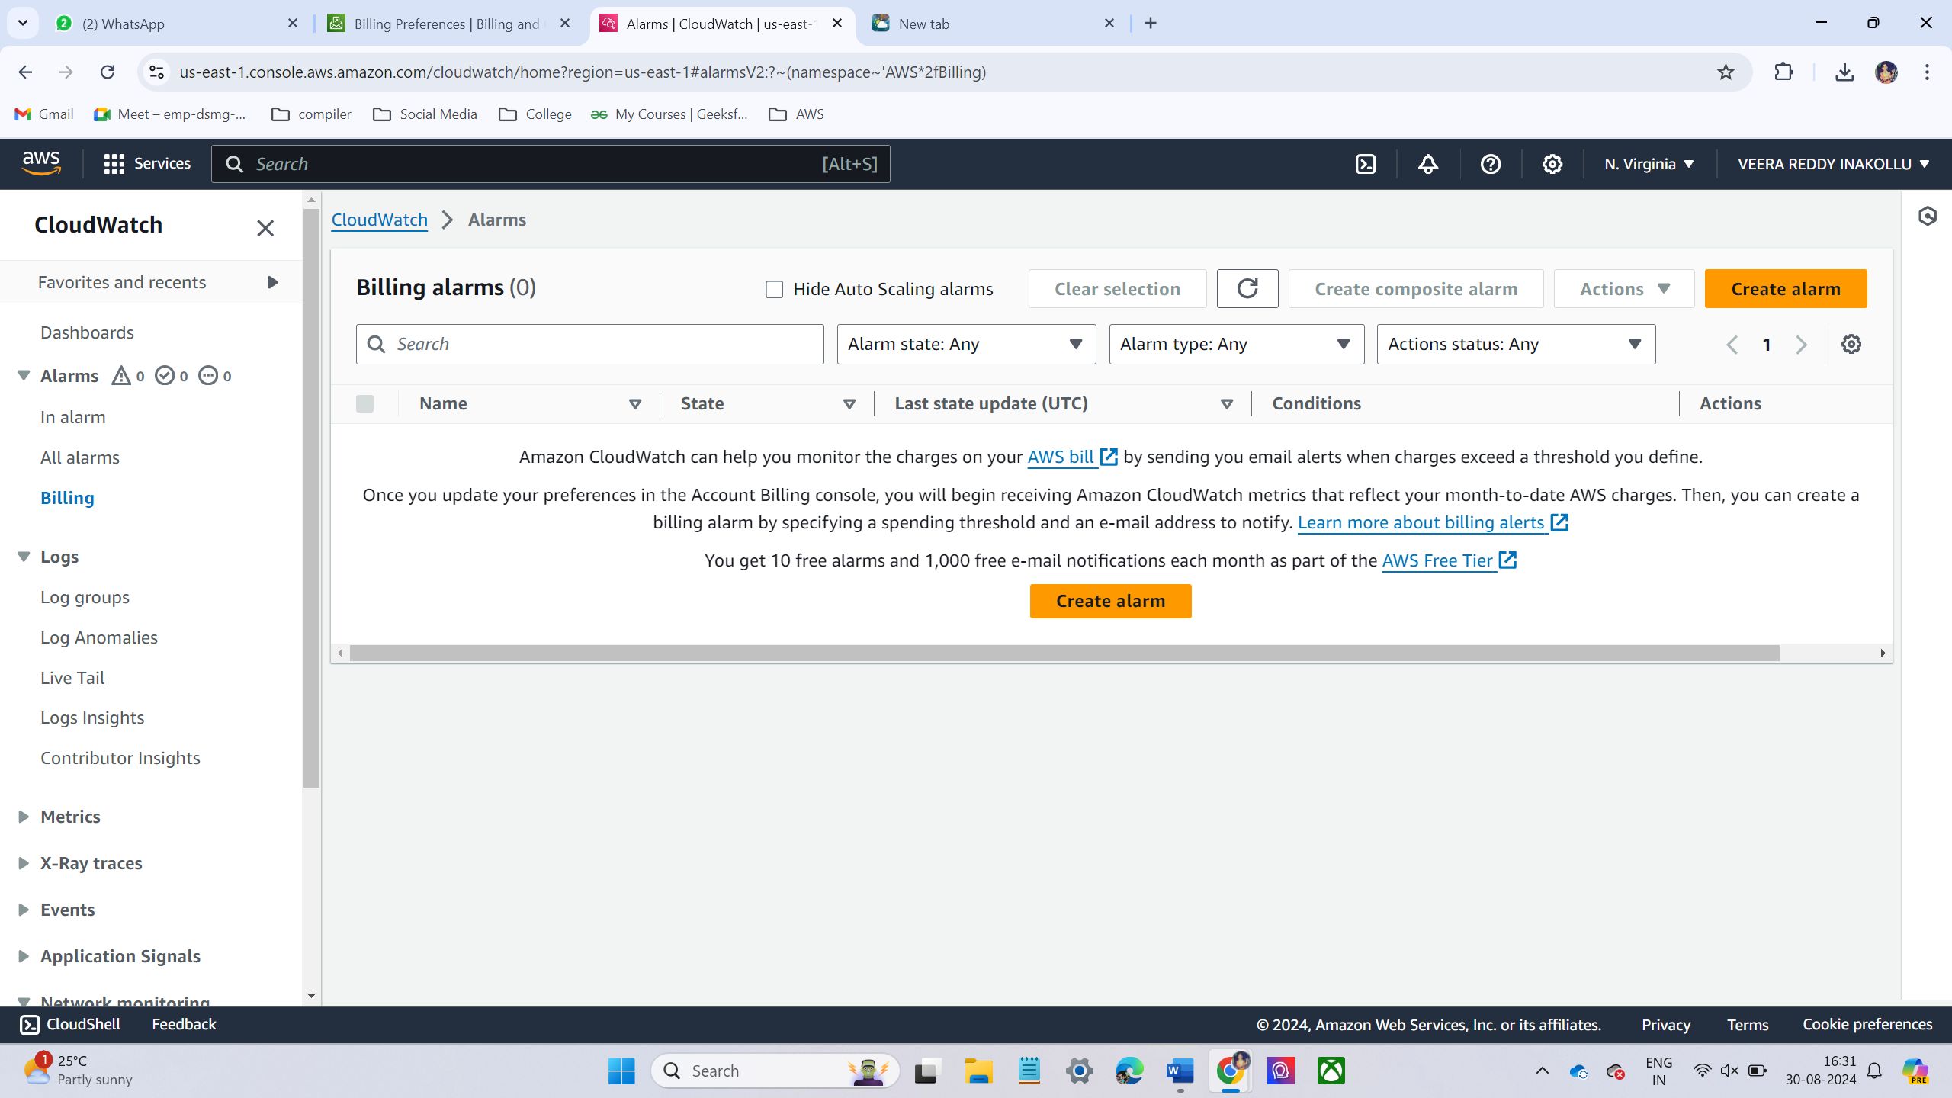

* I have choose threshold value is $1

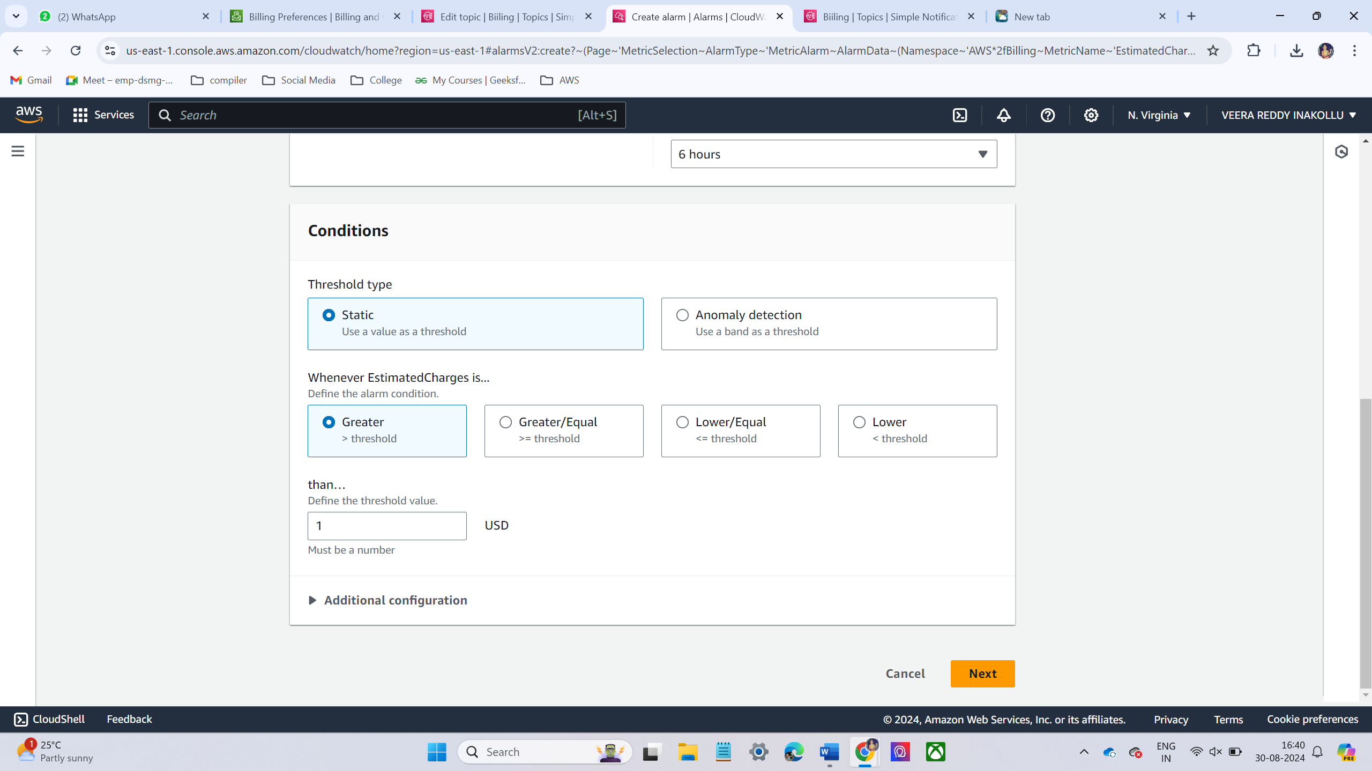

* Give alarm name(your choice)

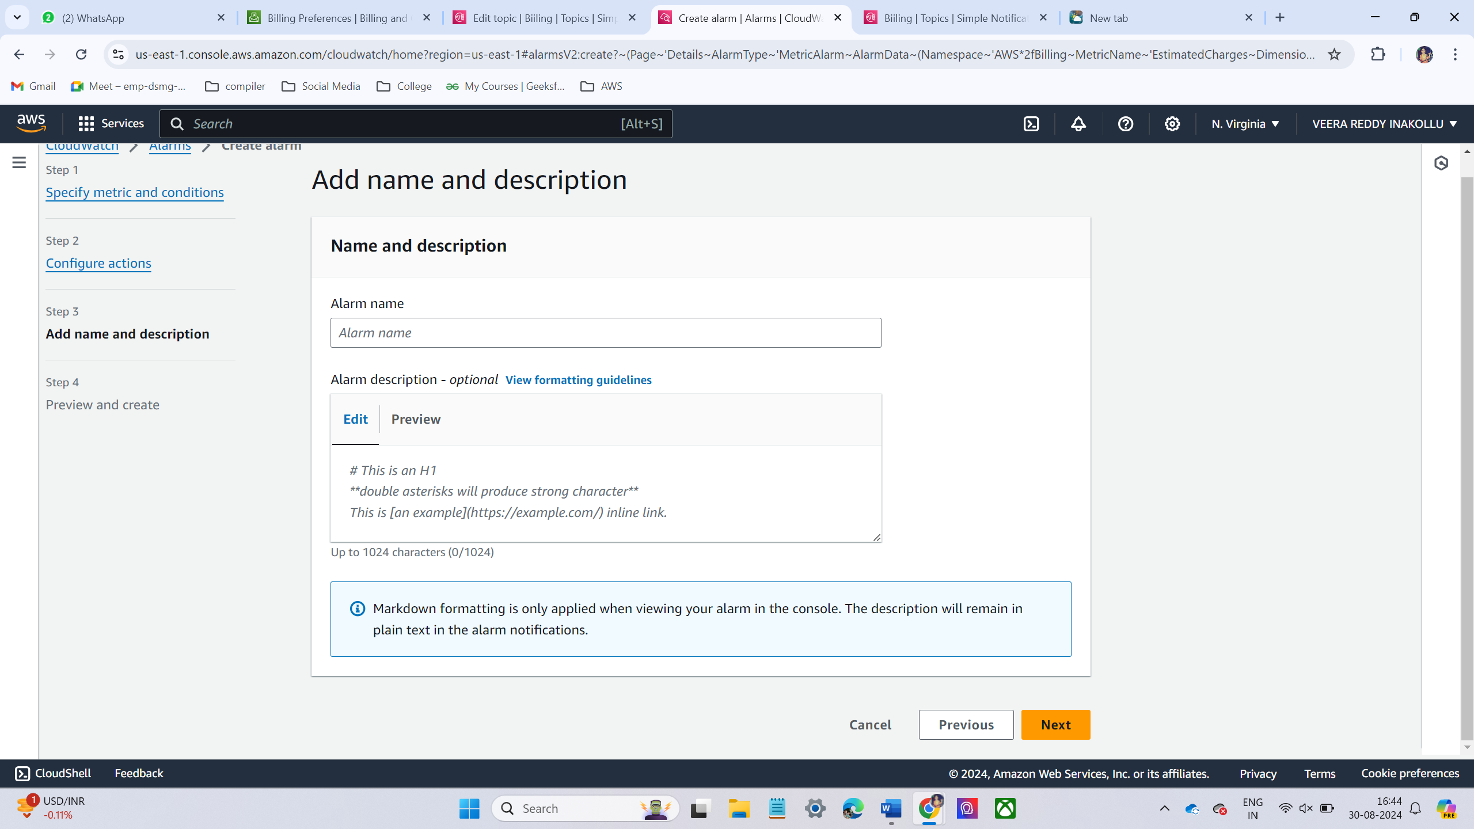

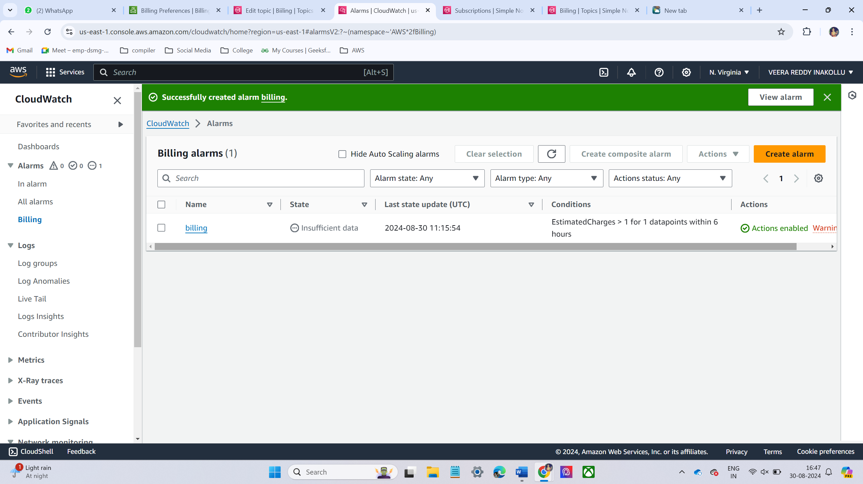

**LAB- 3 🡪 S3 Bucket**

* Create S3 bucket. Make sure that to give unique name

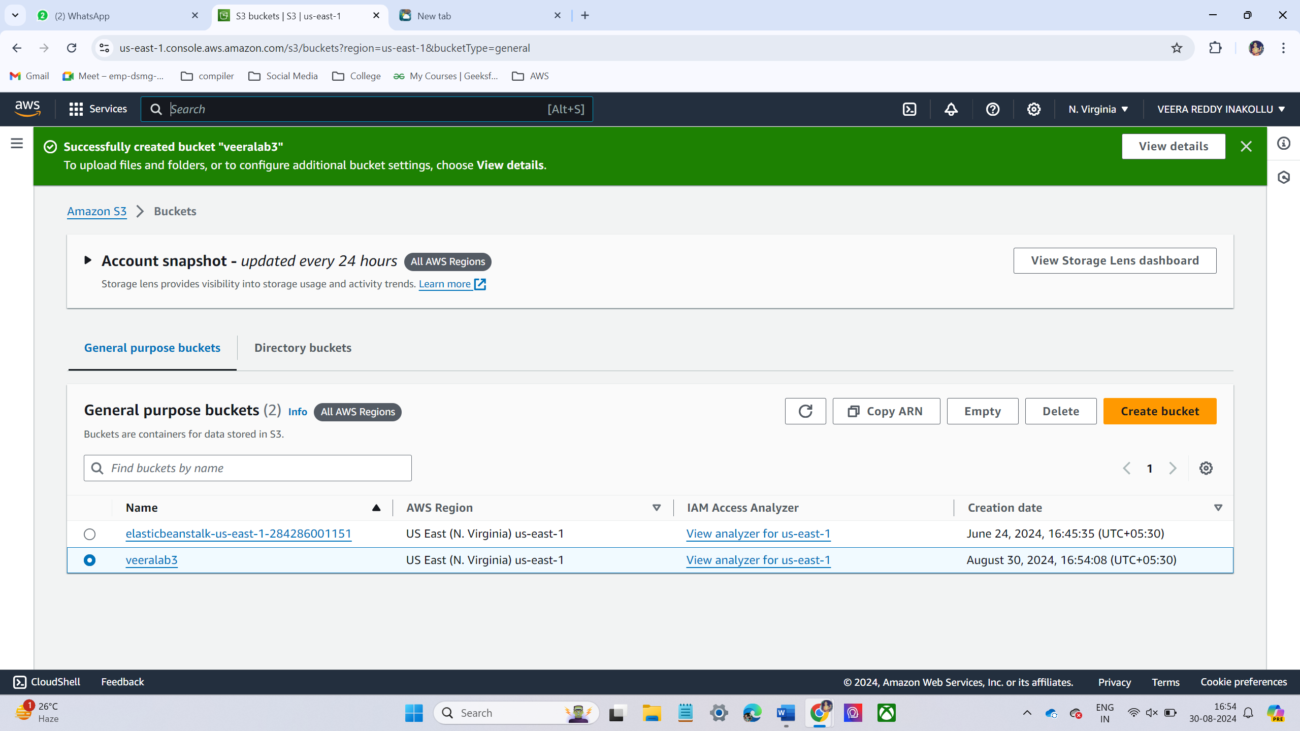

* Upload some text files into the created bucket.

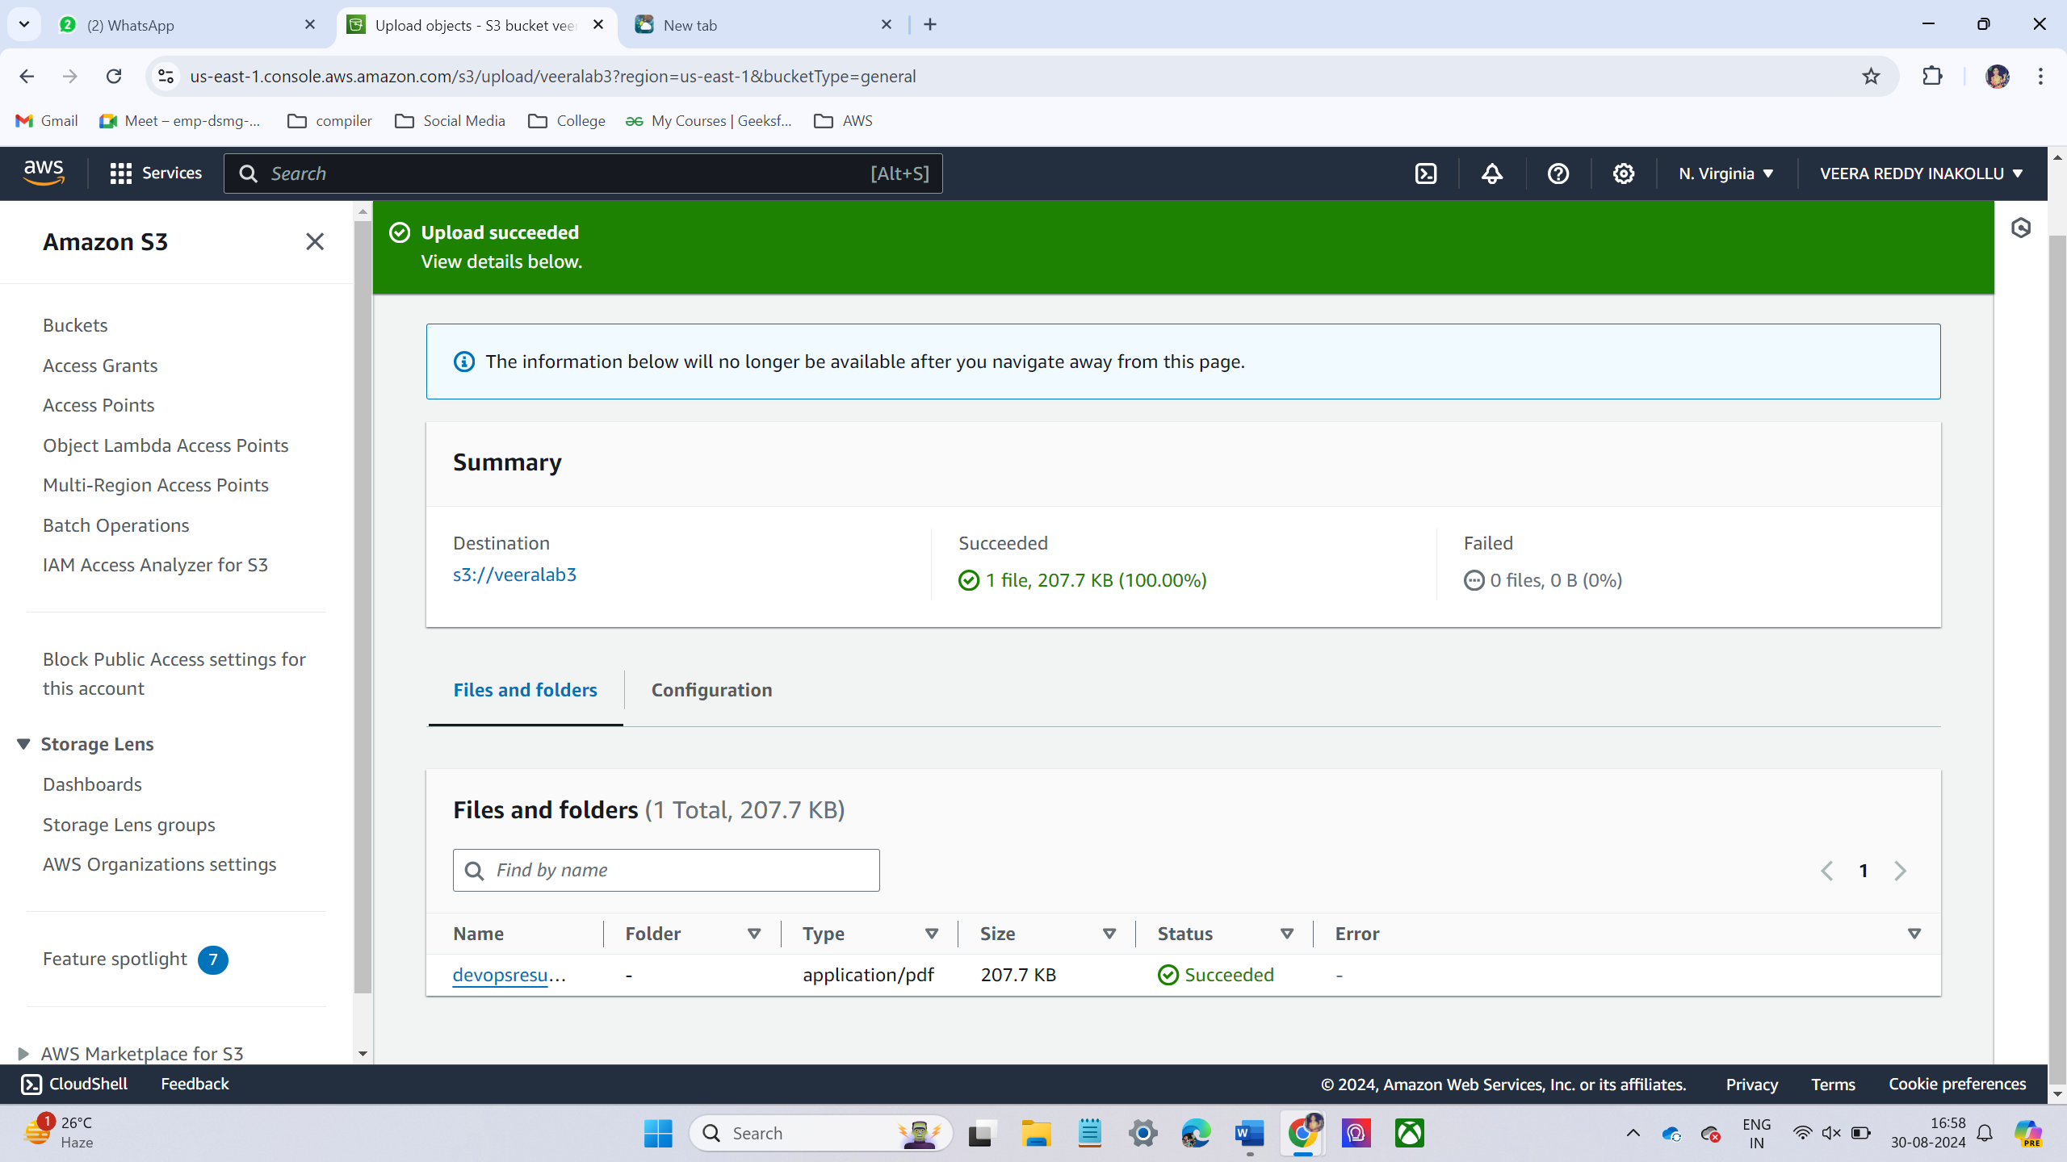

* Just copy the file url and browse the click it shows an error. Because the file is not public access permissions.

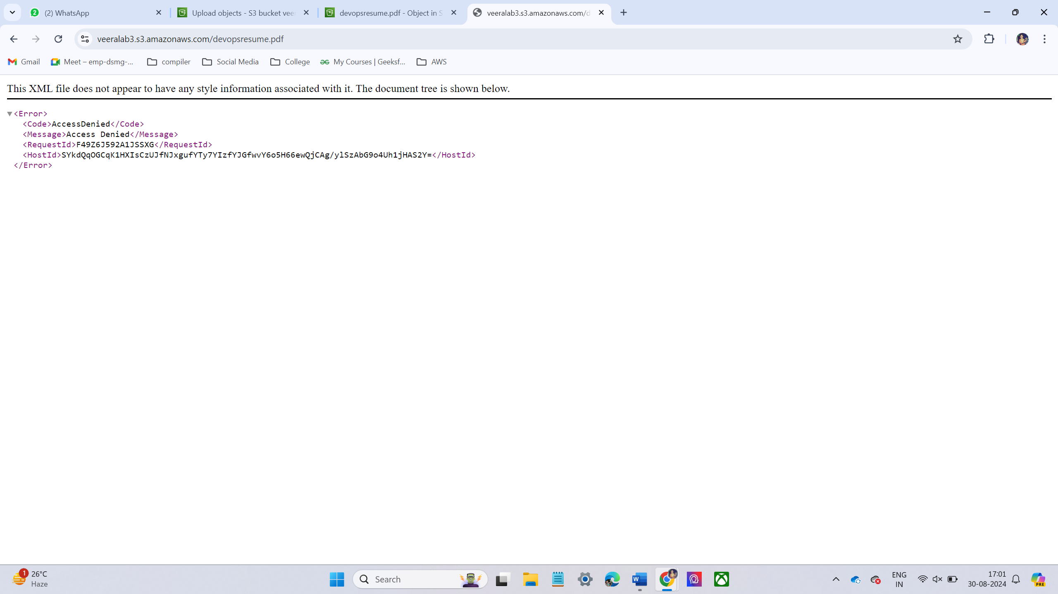

* Now give the permissions
* First give permissions to the bucket. Go to bucket under bucket go to permissions tab. In permissions tab disabled **block public access**. Then scroll down to up to **Access control list (ACLs),** then click edit give public access.

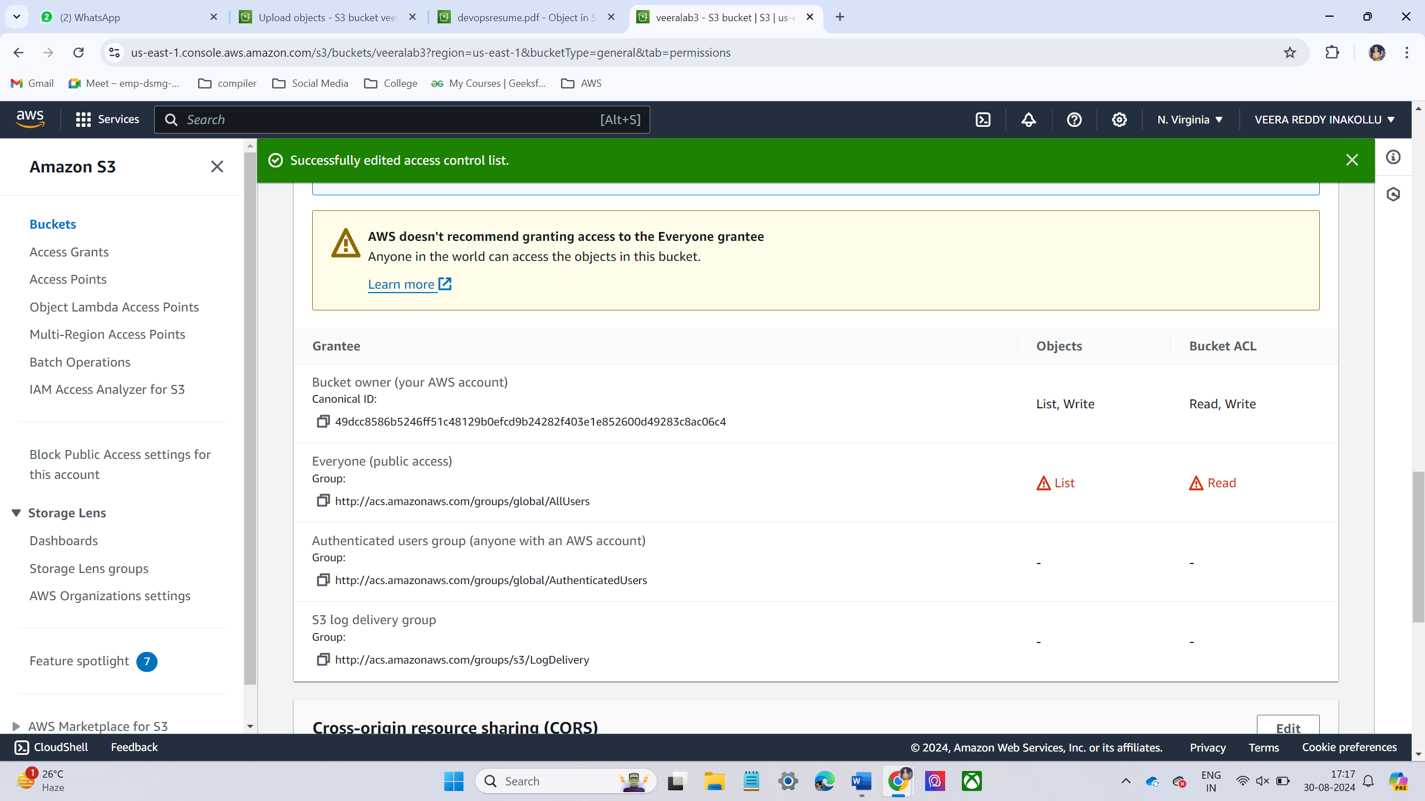

* Now go to inside the bucket click the file and go to permission tab give the public access

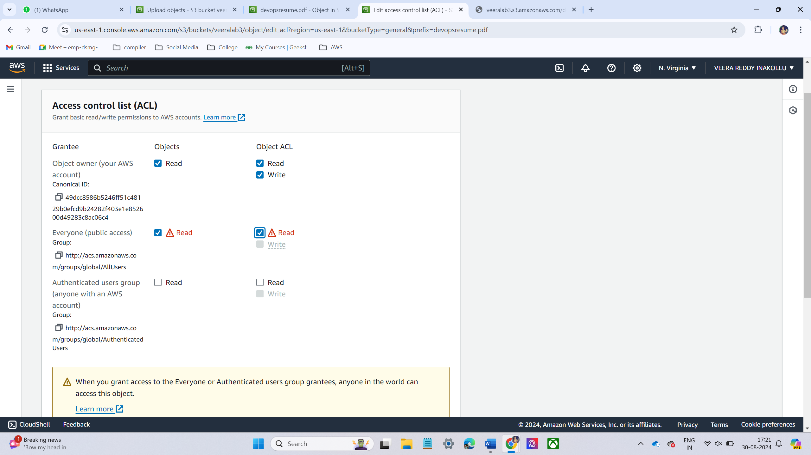

* Now copy the file url and browse the url it will display.

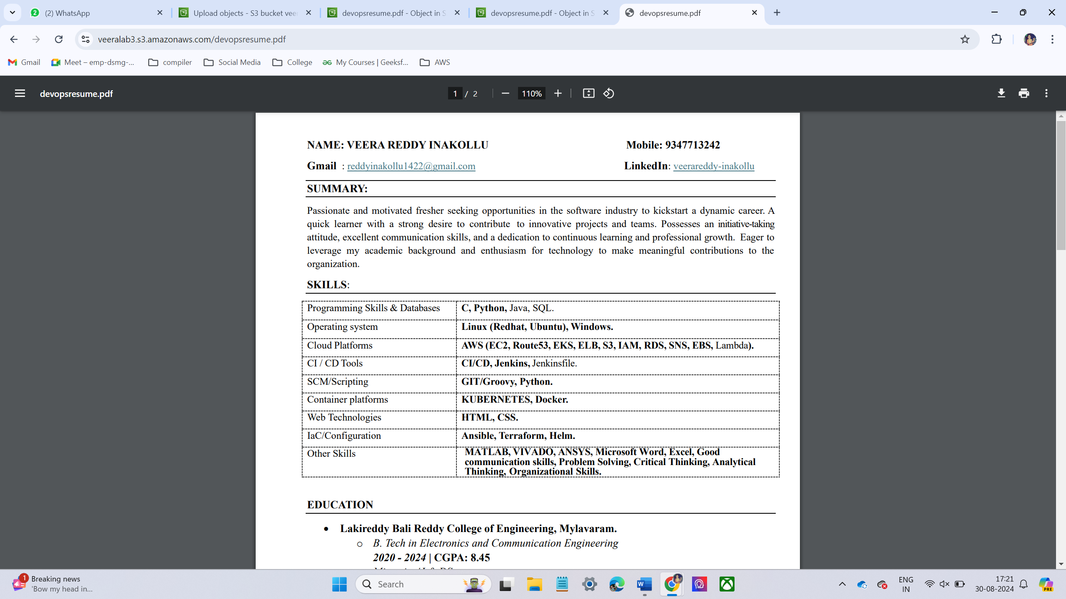

**Step – 2:**

* Enable the versioning of the excited bucket.

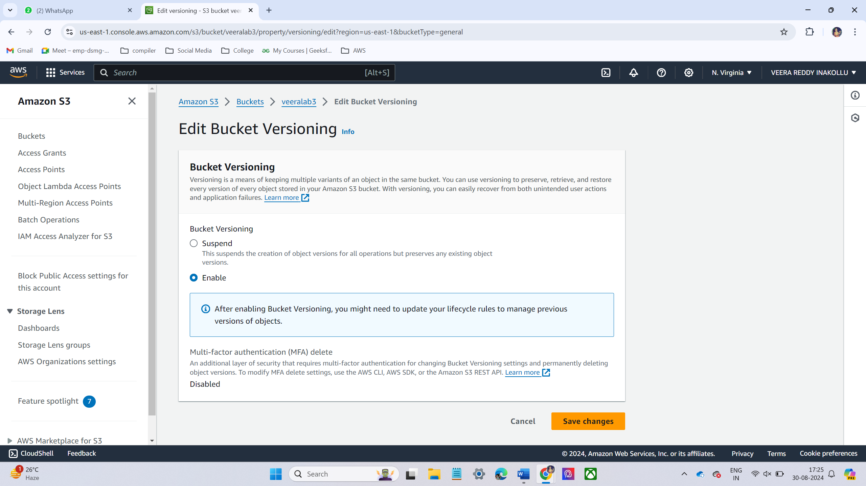

* Upload the some text file in the versioning bucket.

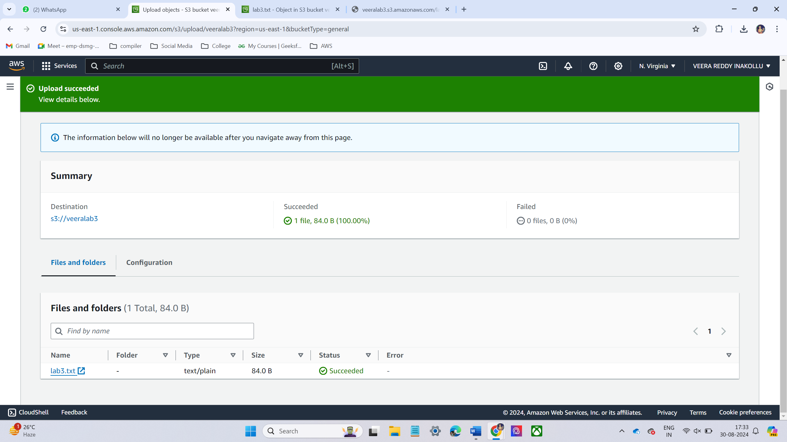

* Now copy the file url and browse the url.

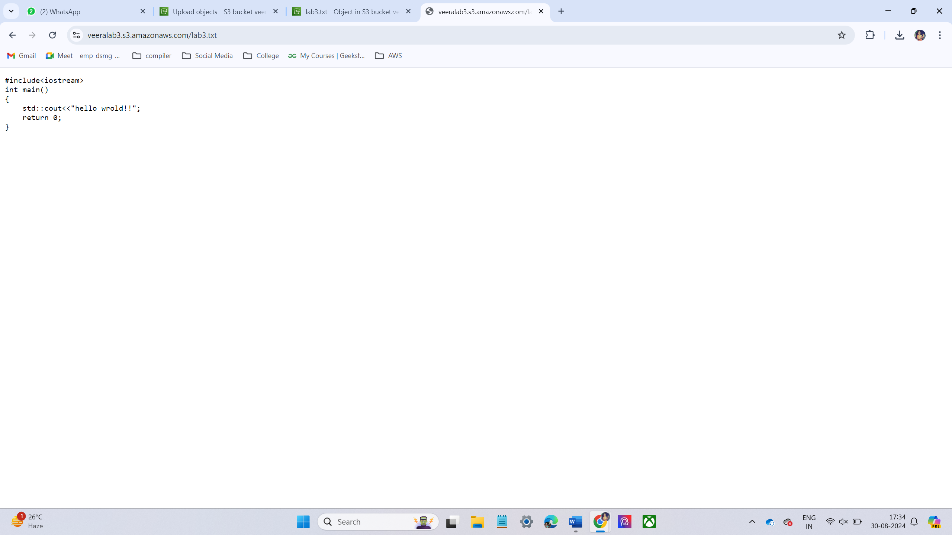

* Now edit the file and update the file and upload the file again and now check the updated content

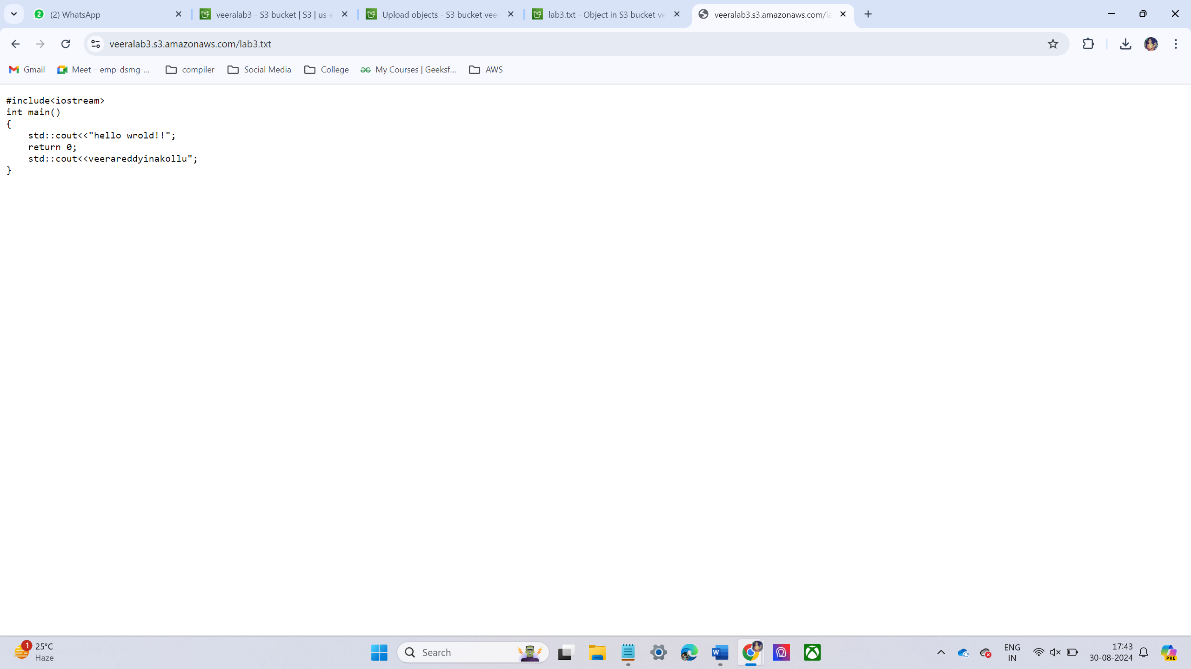

**Step-3**

* Delete text file from the bucket

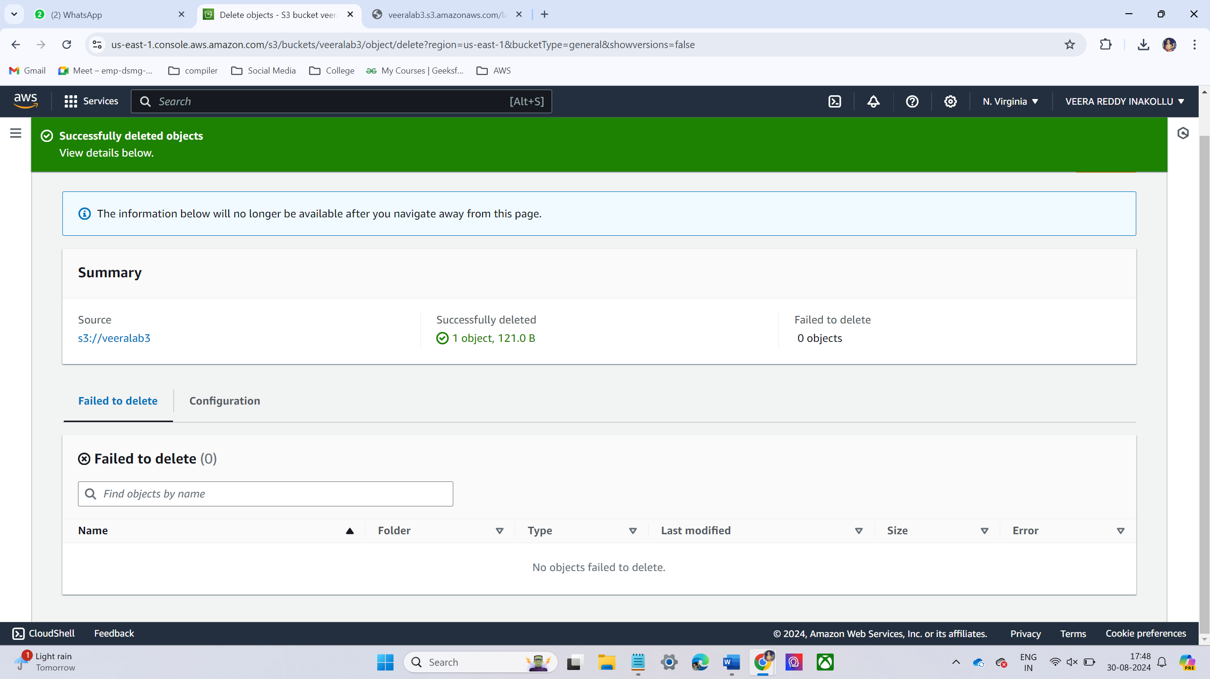

* Then Browse the previous URL it’s shown an error.

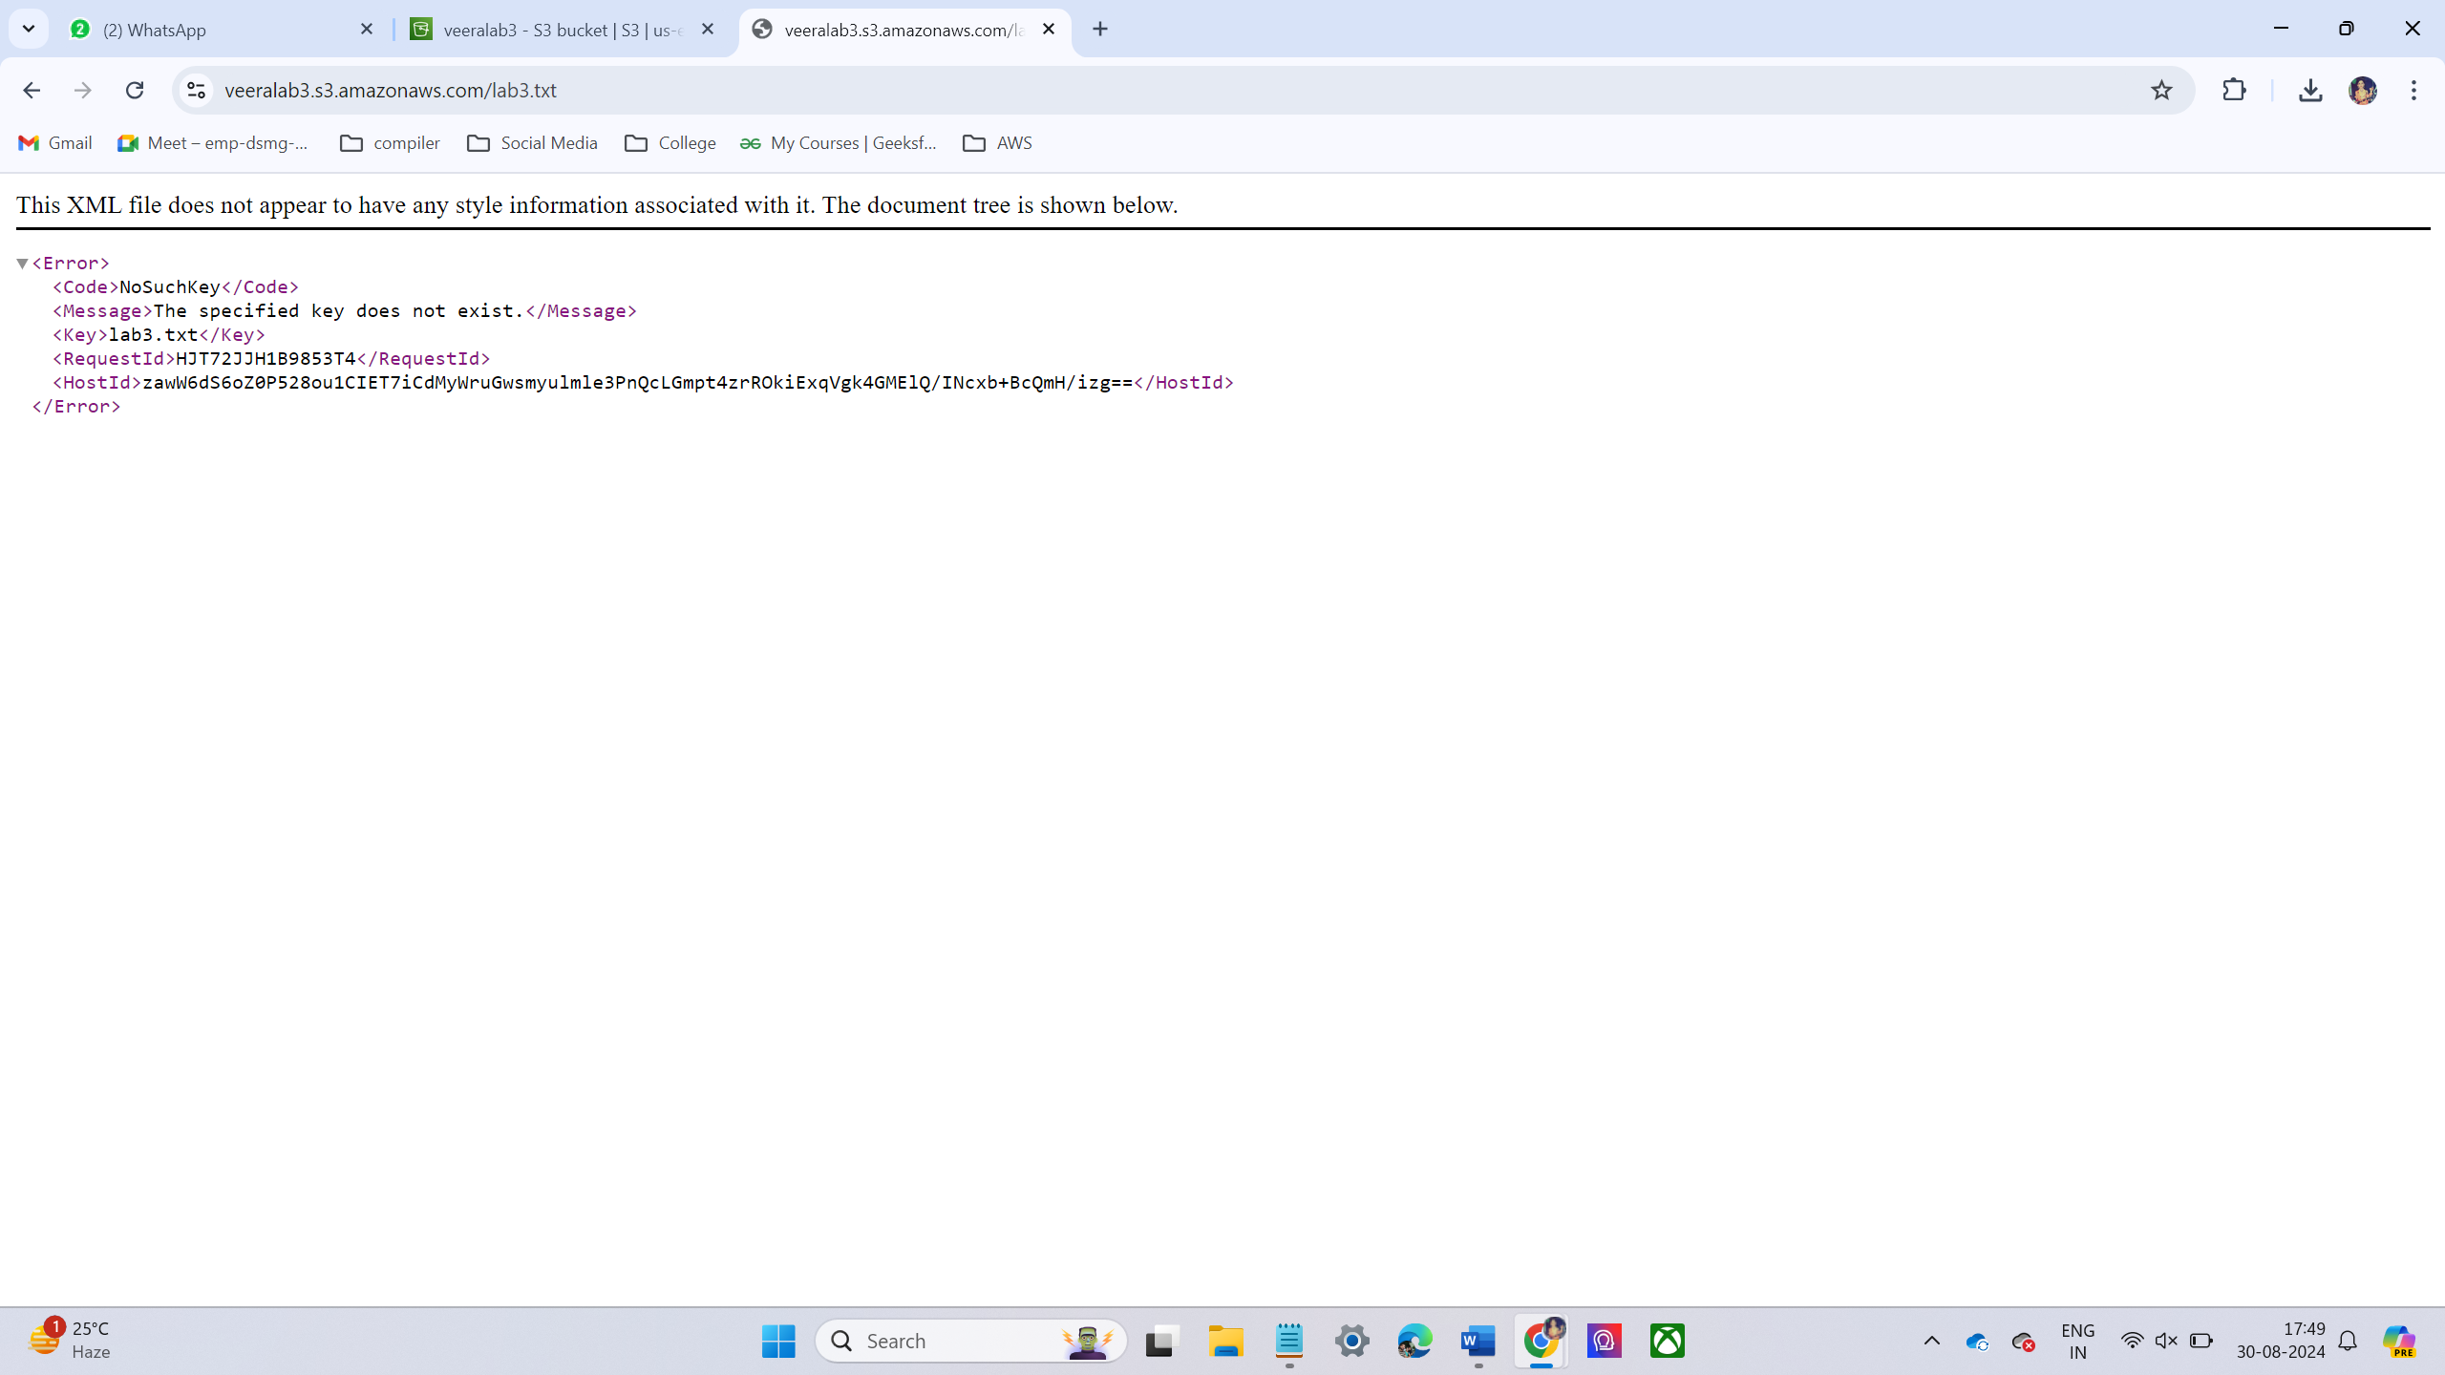

* To recover the deleted file by using version technology. We are previously added versions in the bucket.
* Then enable the version. In that place we have seen the deleted files then select the file and deleting it will restore the last updated file.
* Then browse the URL it will display the content of the file.

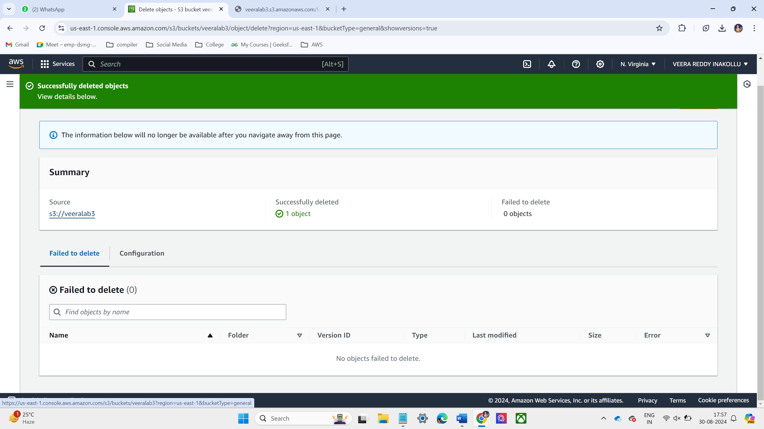

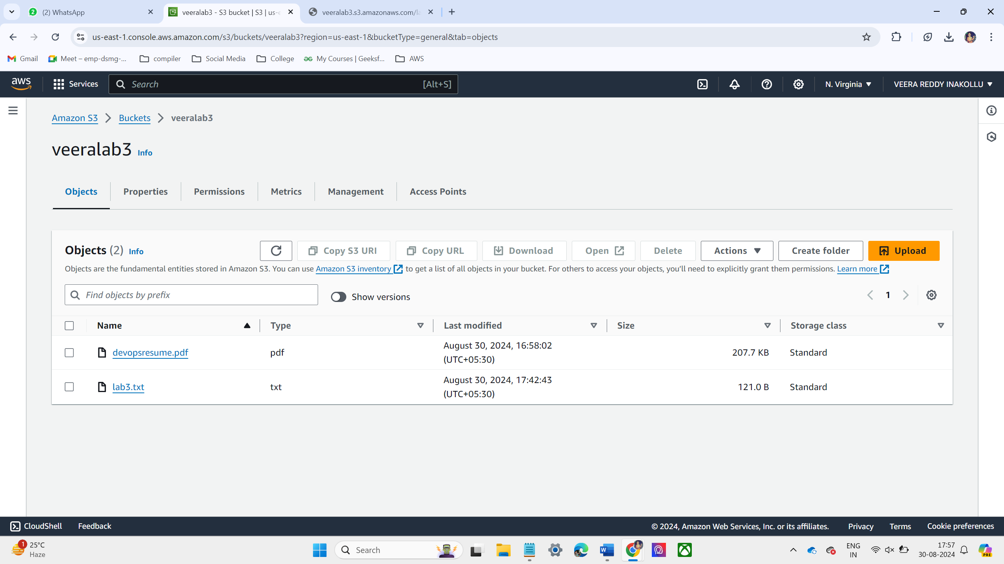

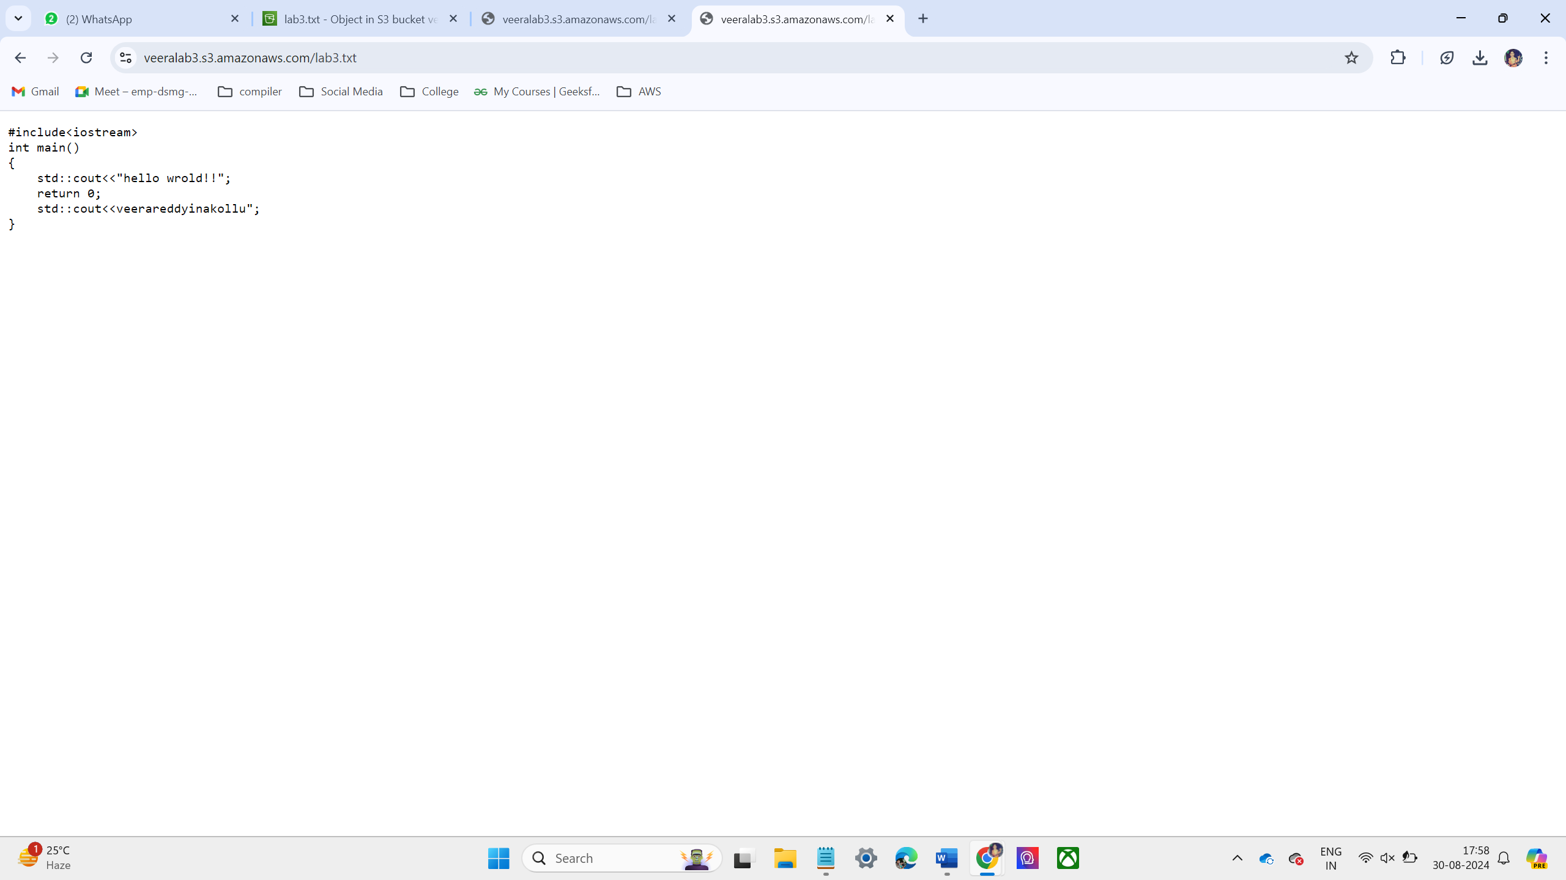

**LAB – 4 EC2 INSTANCE**

* Go to ec2 console and launch ec2 instance.

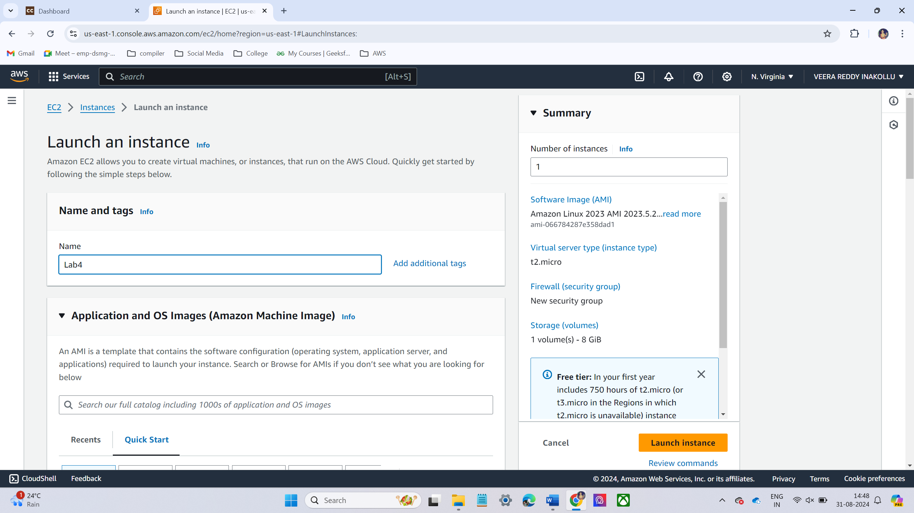

* Now I have select Ubuntu operating system.

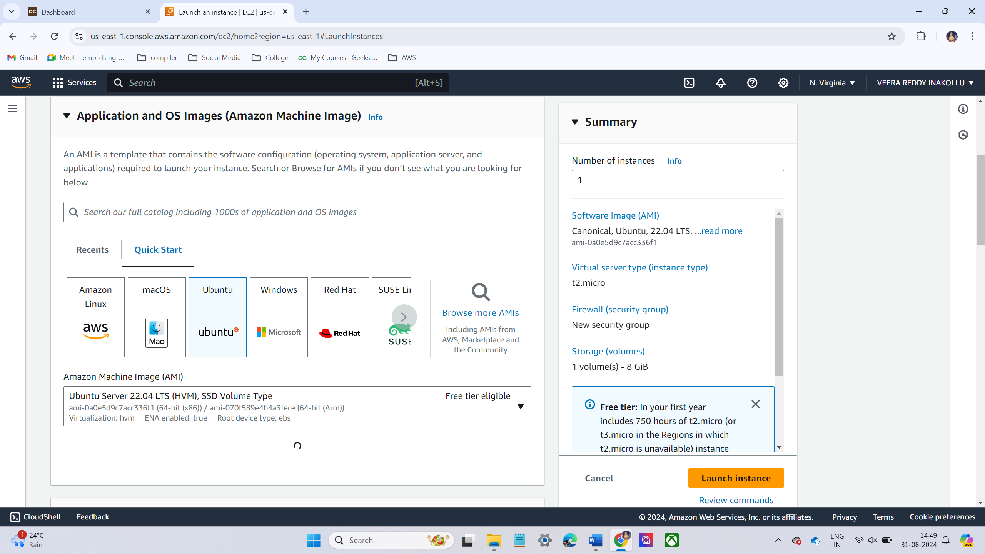

* Instance type t2.micro

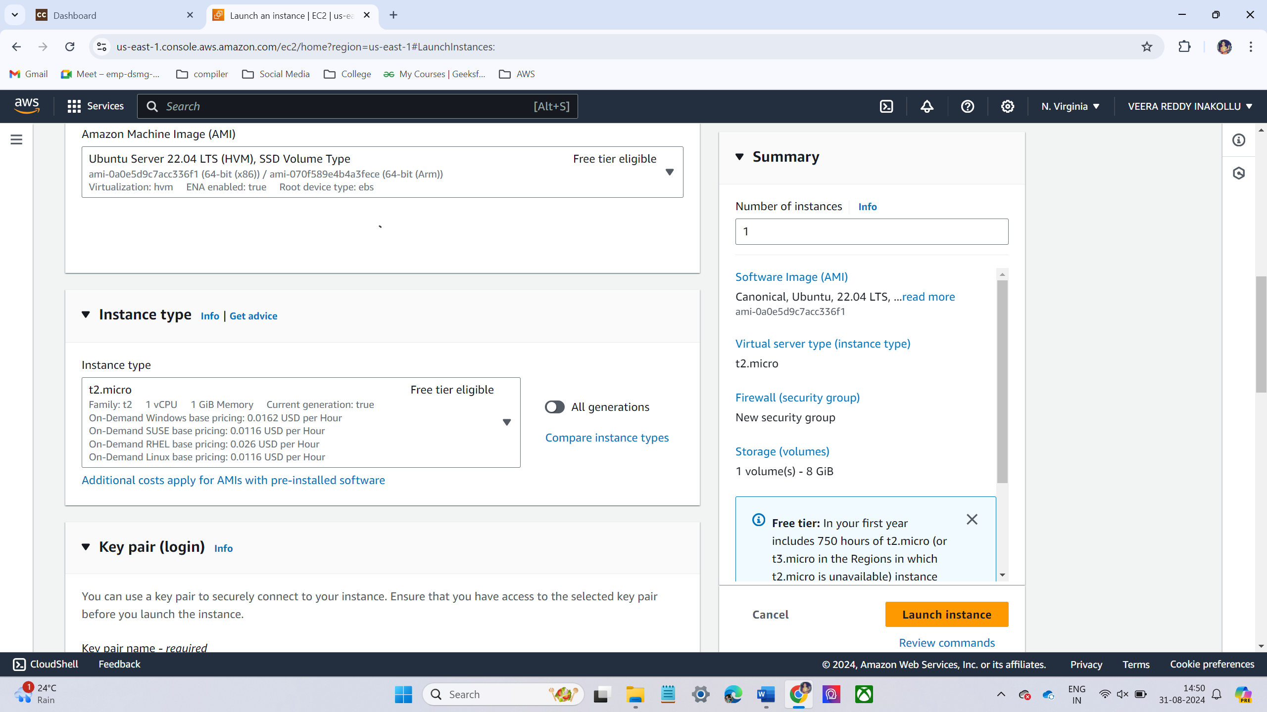

* Allow required port in the security group it can access from the outside.

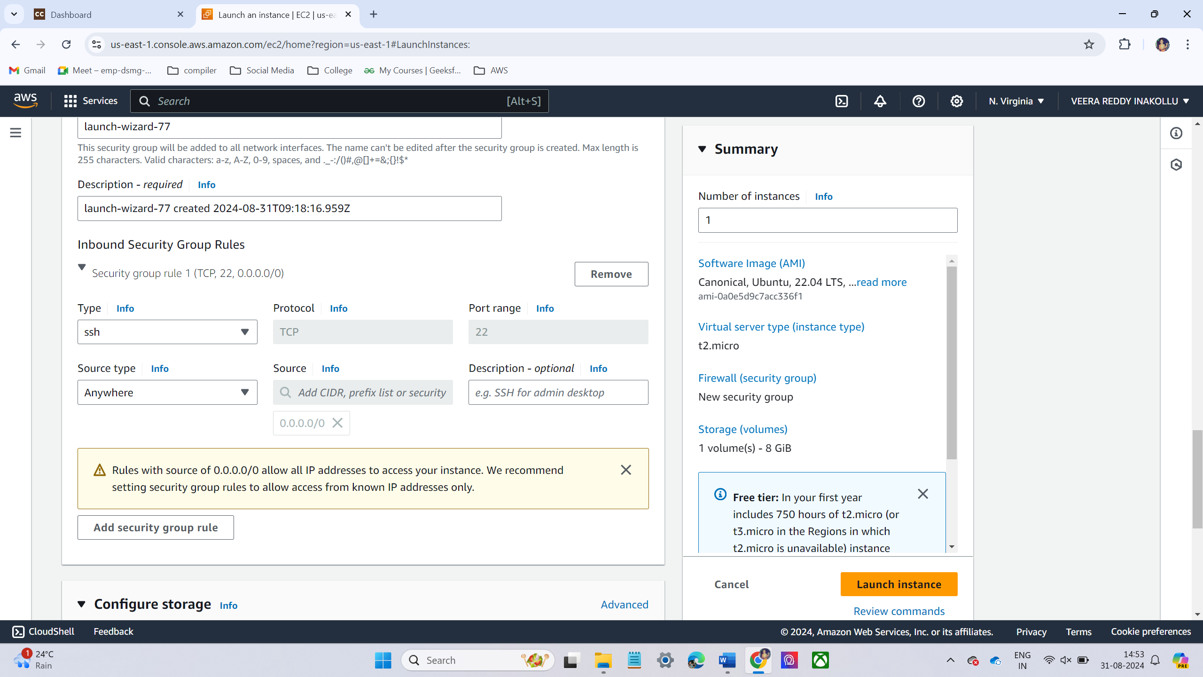

* Now Launch instance

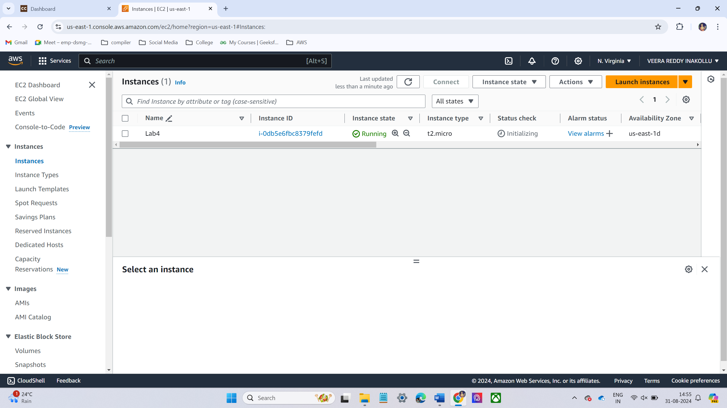

* Now I have access instance using ppk file in putty software.

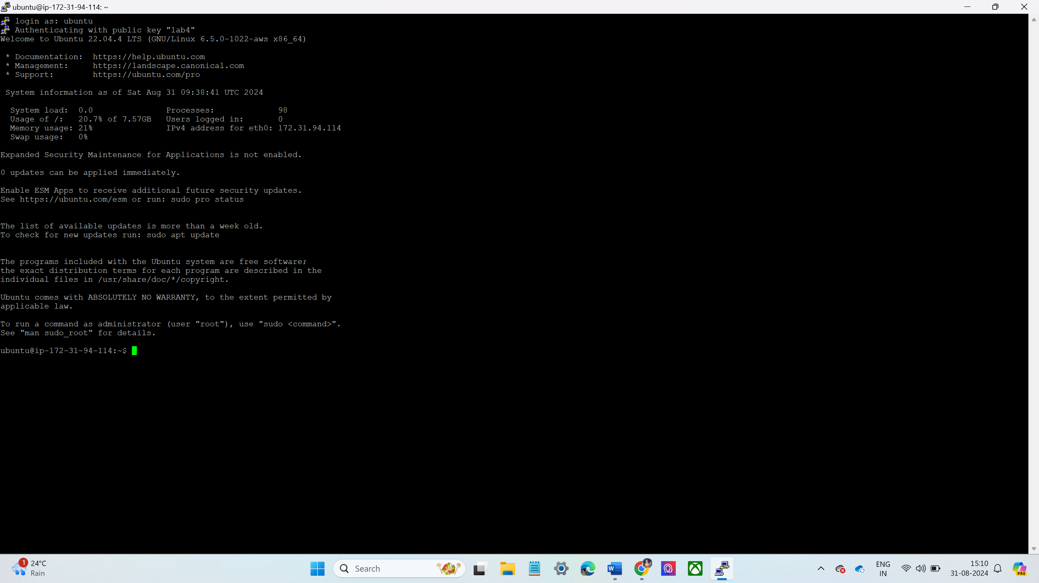

**LAB – 5 SECURITY GROUPS**

* Create new security group
* Goto ec2 console and click security groups and select new security group
* Choose the name of the security group.
* And select your VPC.

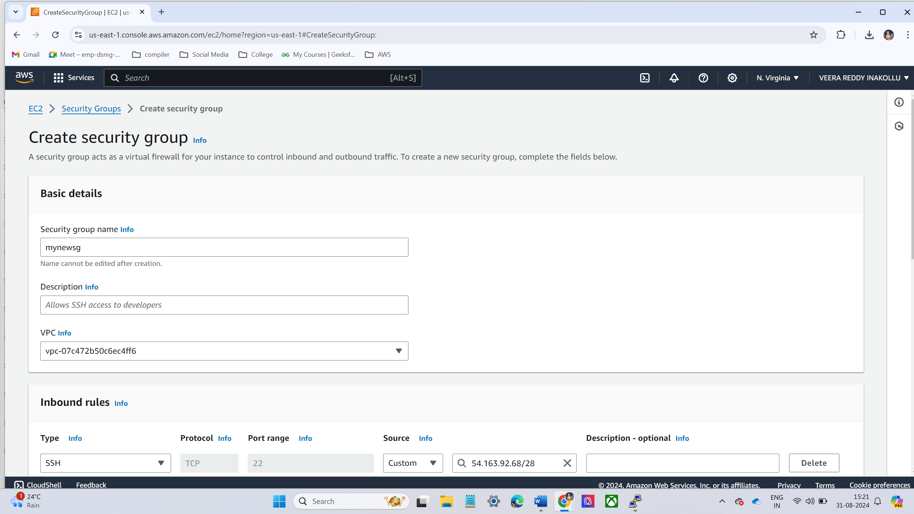

* Allow Inbound Port 80 and 22 from IP Address (IP/28 Range)
* Click **Edit Inbound Rules**.
* Add rules:
  + **Type**: SSH
    - **Protocol**: TCP
    - **Port Range**: 22
    - **Source**: Select **My IP** and adjust to **IP/28** range (for dynamic IP changes). For example, if IP is 54.163.92.68 use 54.163.92.68/28.
  + **Type**: HTTP
    - **Protocol**: TCP
    - **Port Range**: 80
    - **Source**: Set the same IP range (e.g., 54.163.92.68/28).

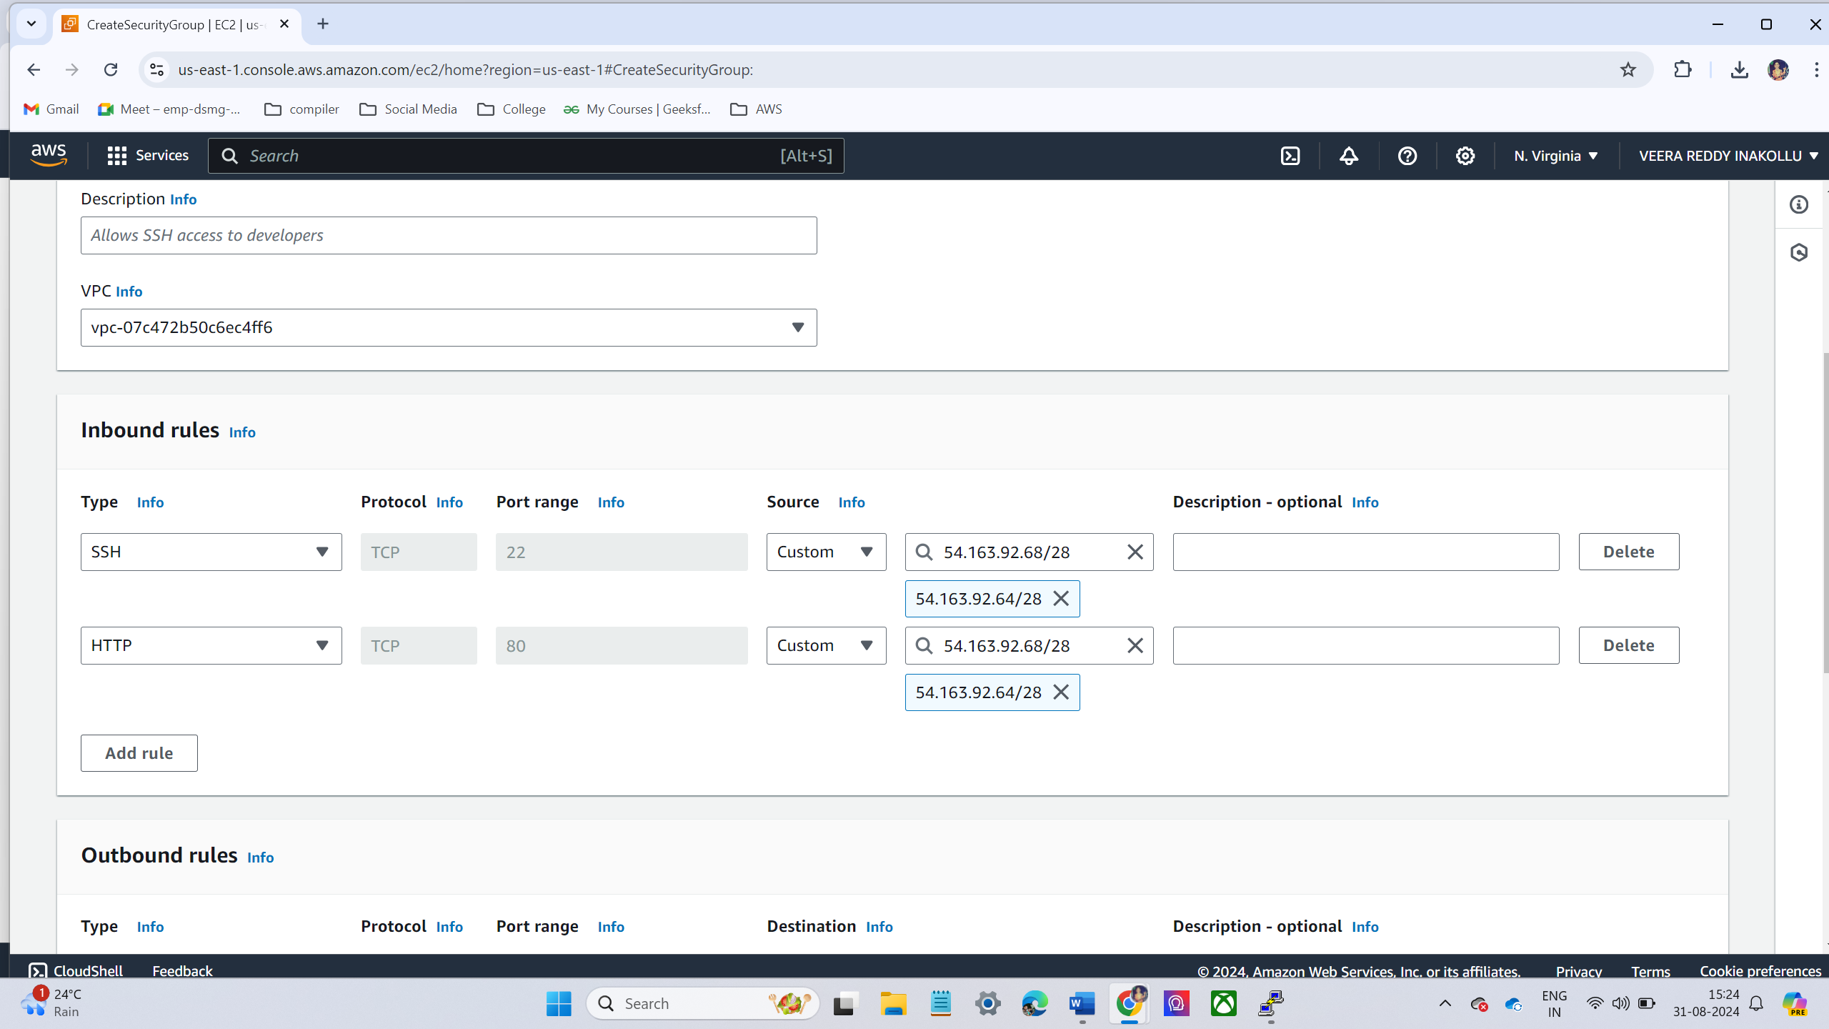

* Now the new security group add to the existing EC2 instance.
* Go to **EC2 Dashboard**.
* Click **Instances** and select the instance you want to modify.
* Under **Actions**, select **Networking** → **Change Security Groups**.

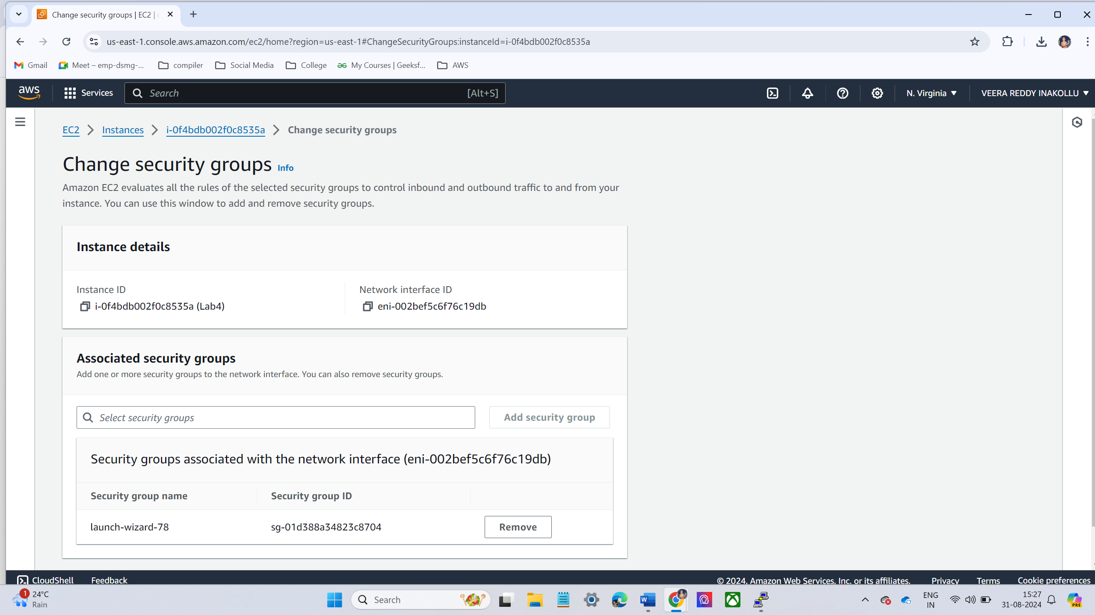

* Attach **mynewsg** to your instance and apply the changes.

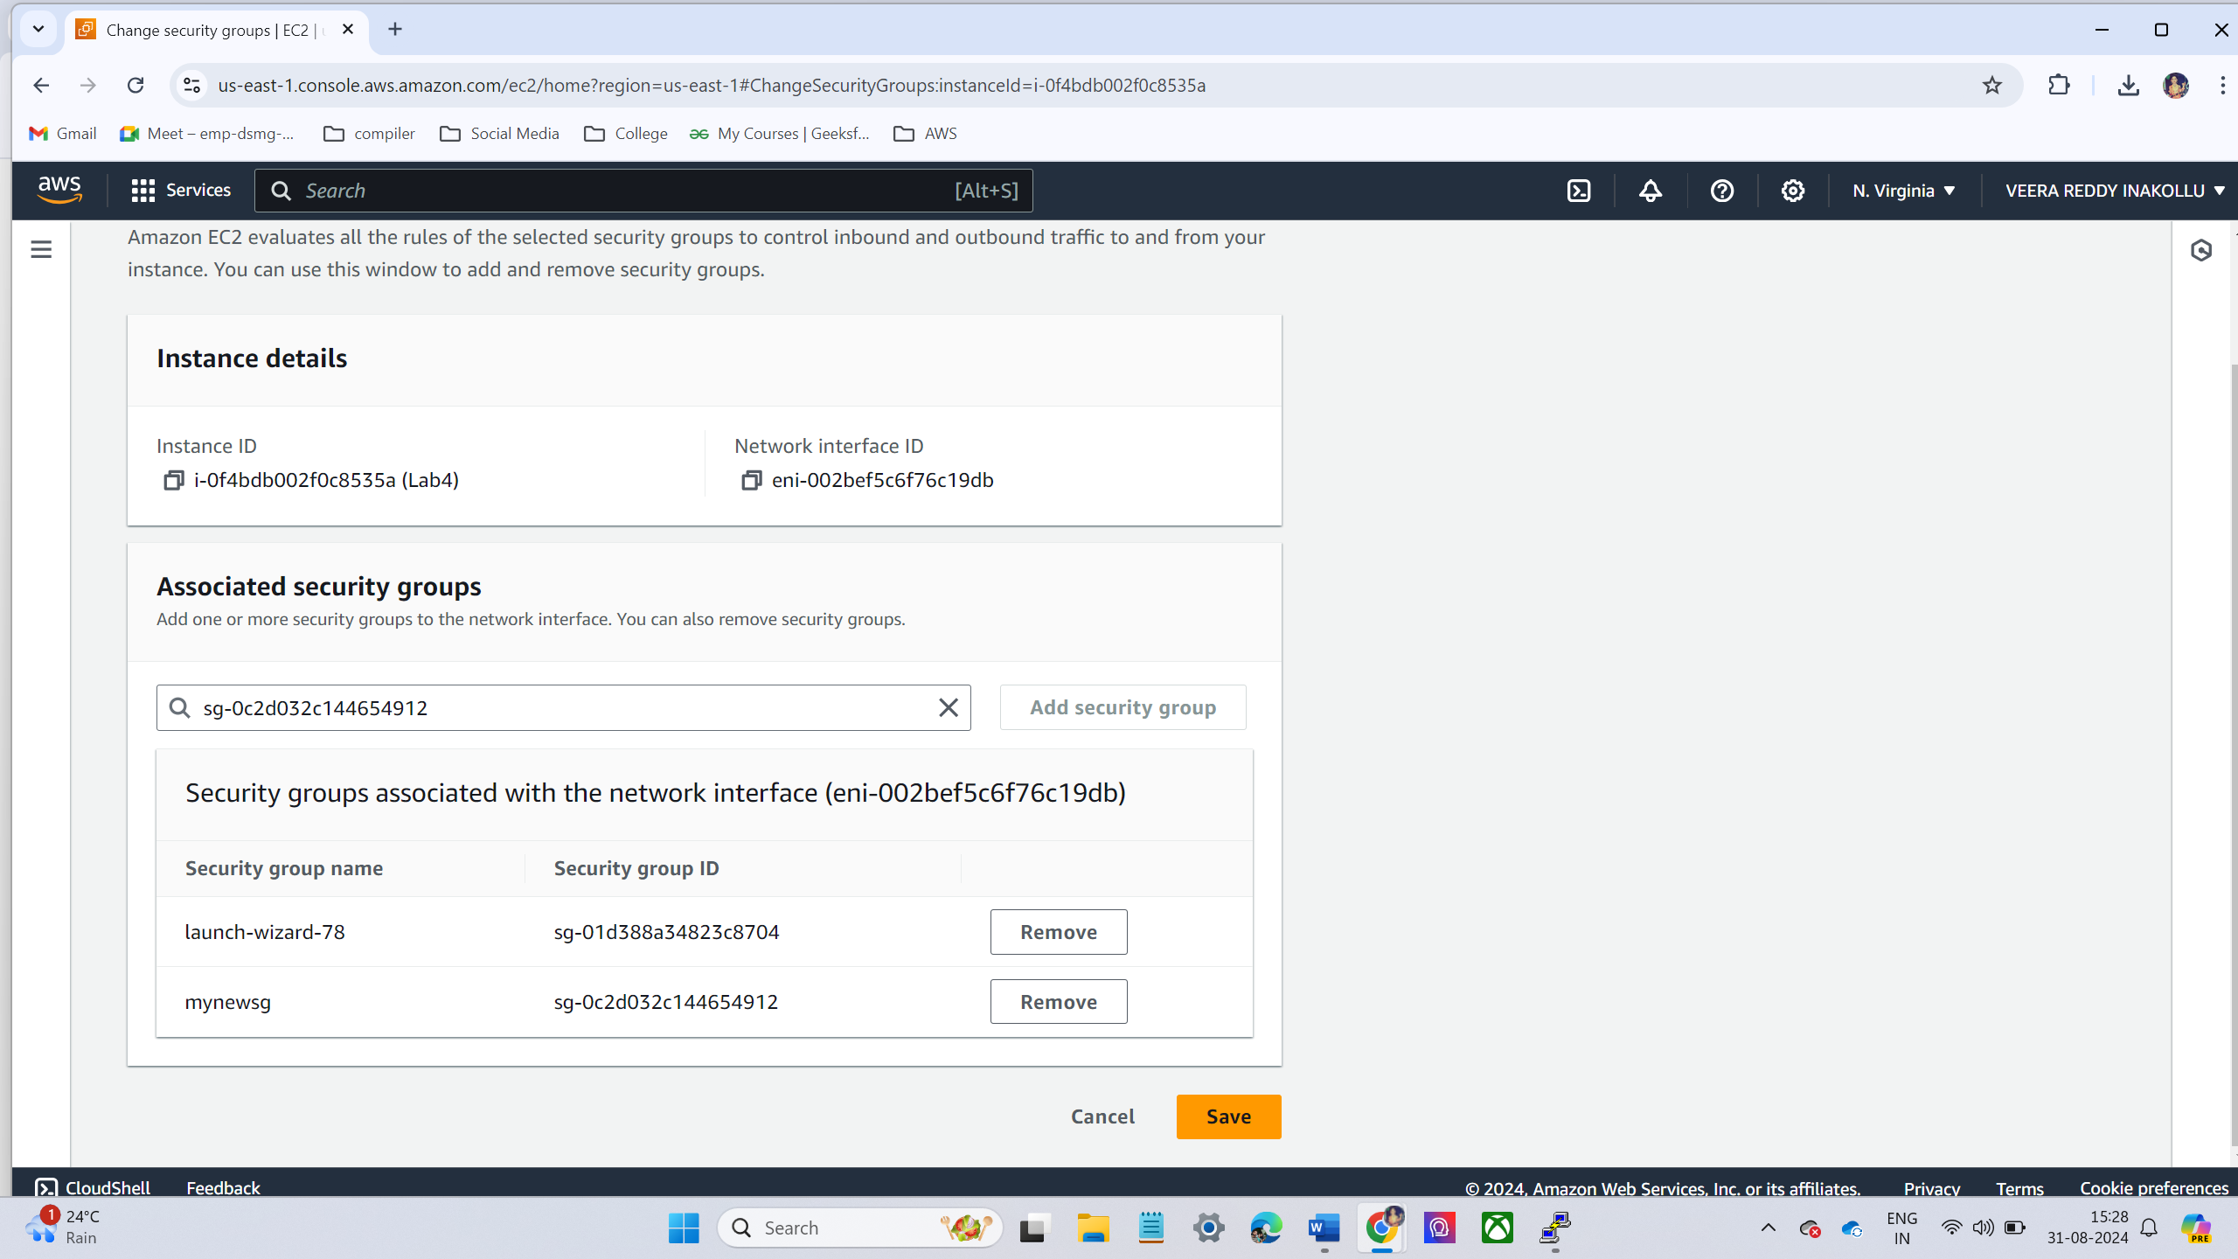

* Access the Server via SSH.
  + Open a terminal (or SSH client).
  + Use the SSH command to connect to EC2 instance.

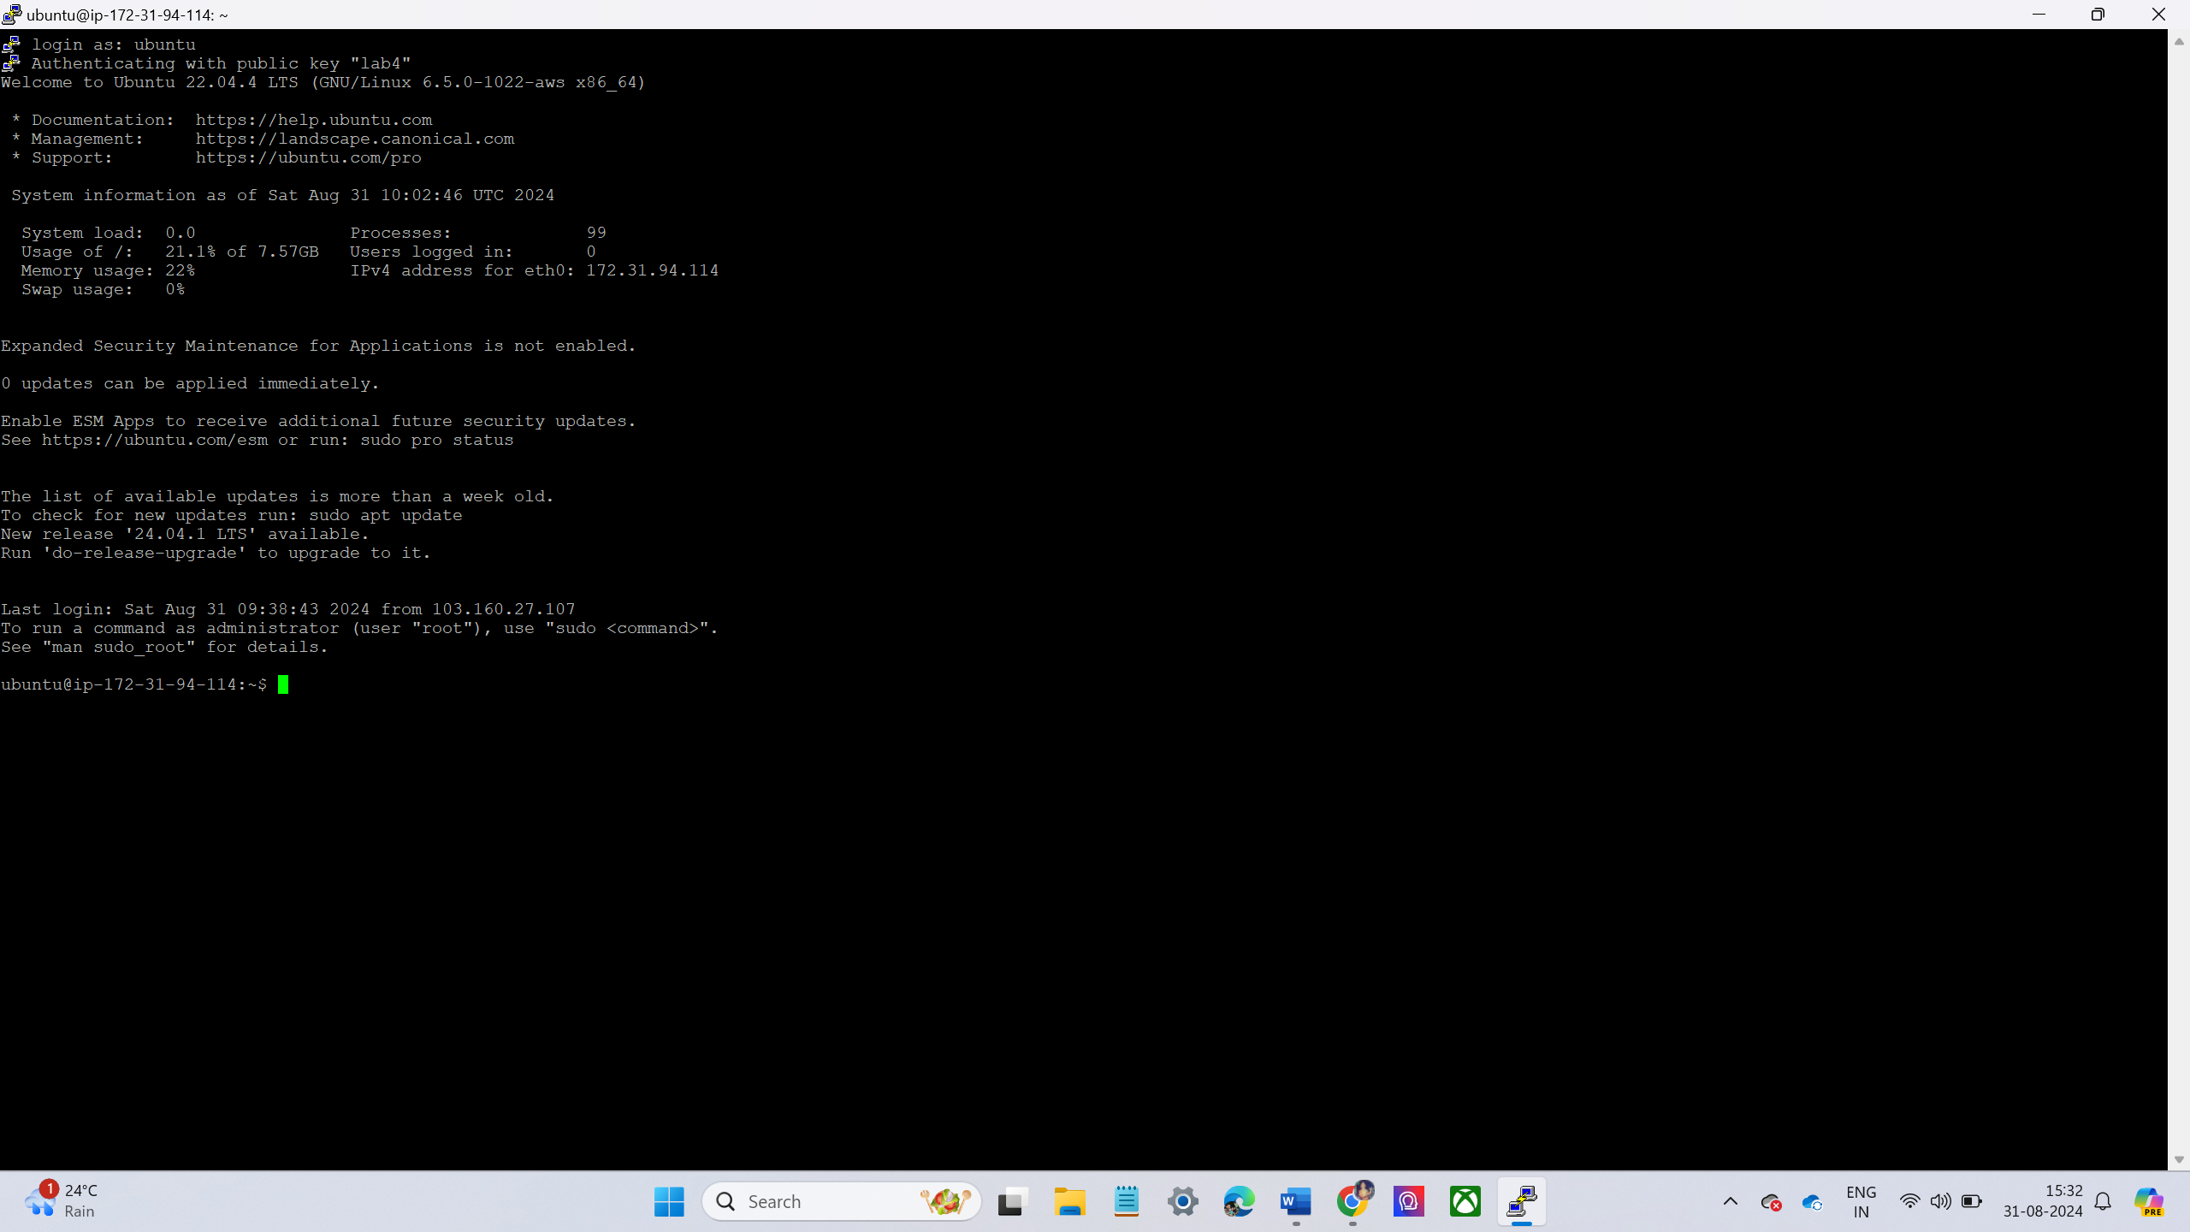

**LAB – 6 -VOLUMES AND SNAPSHOTS**

* Create a 5GB Volume and Attach It to the Running EC2 Instance
* Navigate to **EC2 Dashboard**.
* On the left-hand side, click on **Volumes** under **Elastic Block Store** (EBS).
* Click **Create Volume**.
  + **Size**: 5 GiB
  + **Availability Zone**: Select the same Availability Zone as your running EC2 instance.

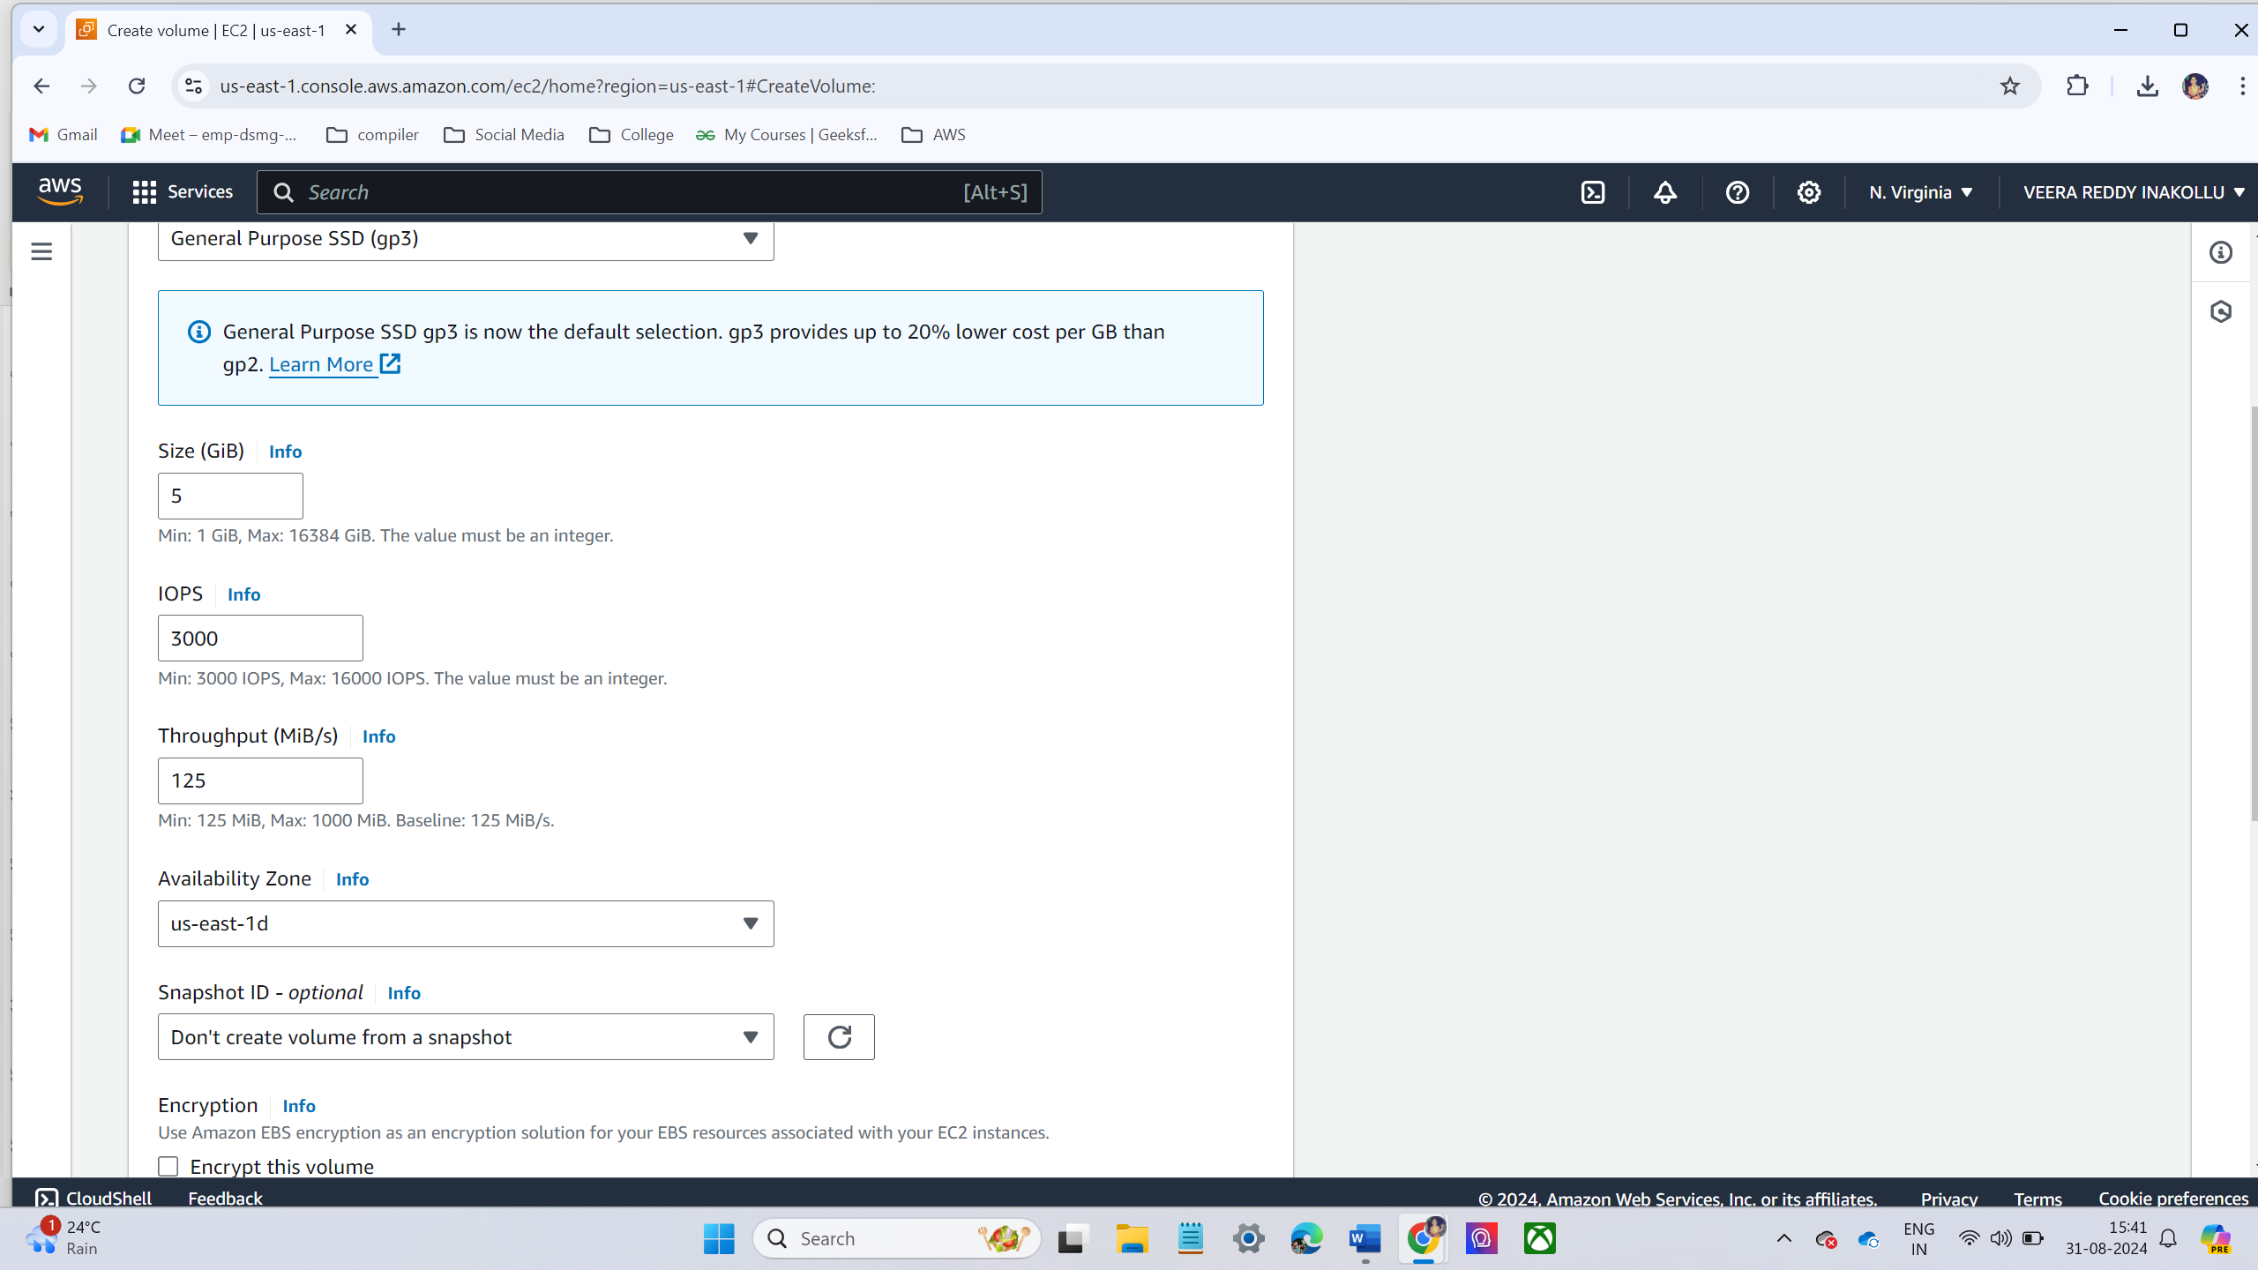

* Volume created successfully.

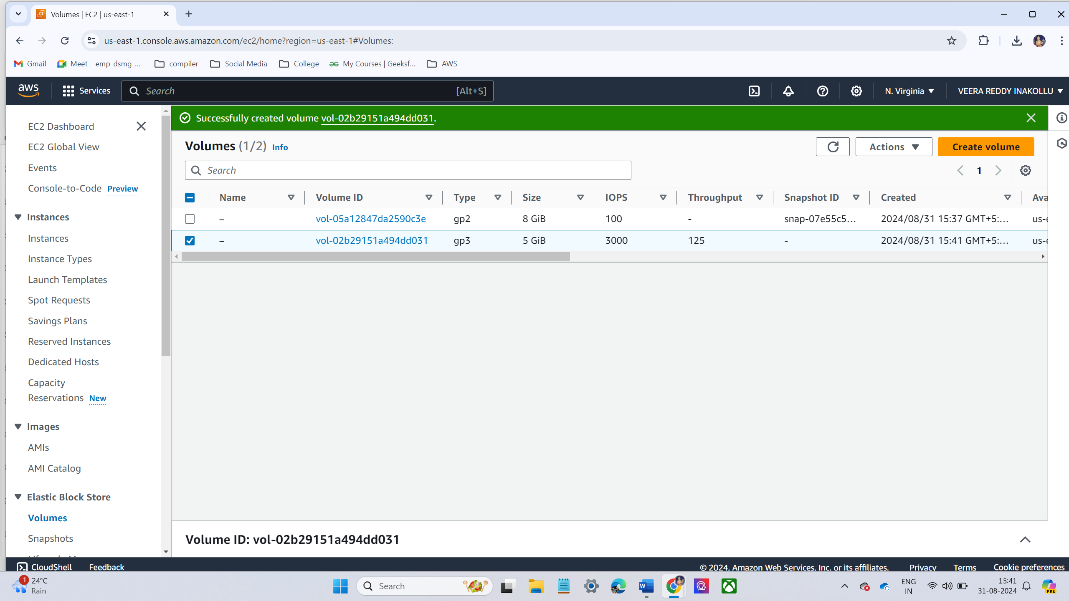

* Once the volume is created, select the volume from the list and click **Actions** → **Attach Volume**.

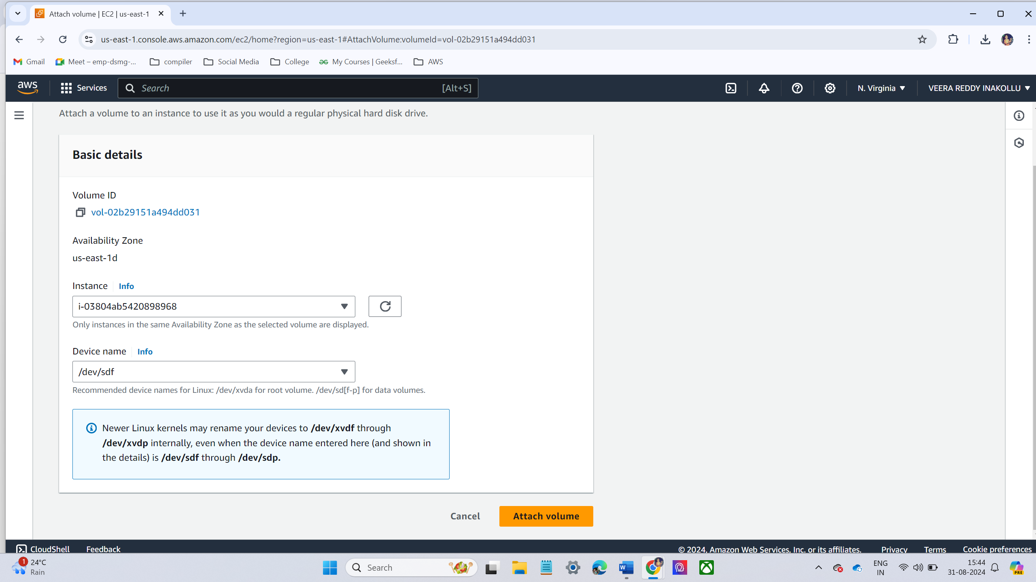

* Put some data in this volume like some testing files
* Connect the ec2 instance in the terminal using ssh command.

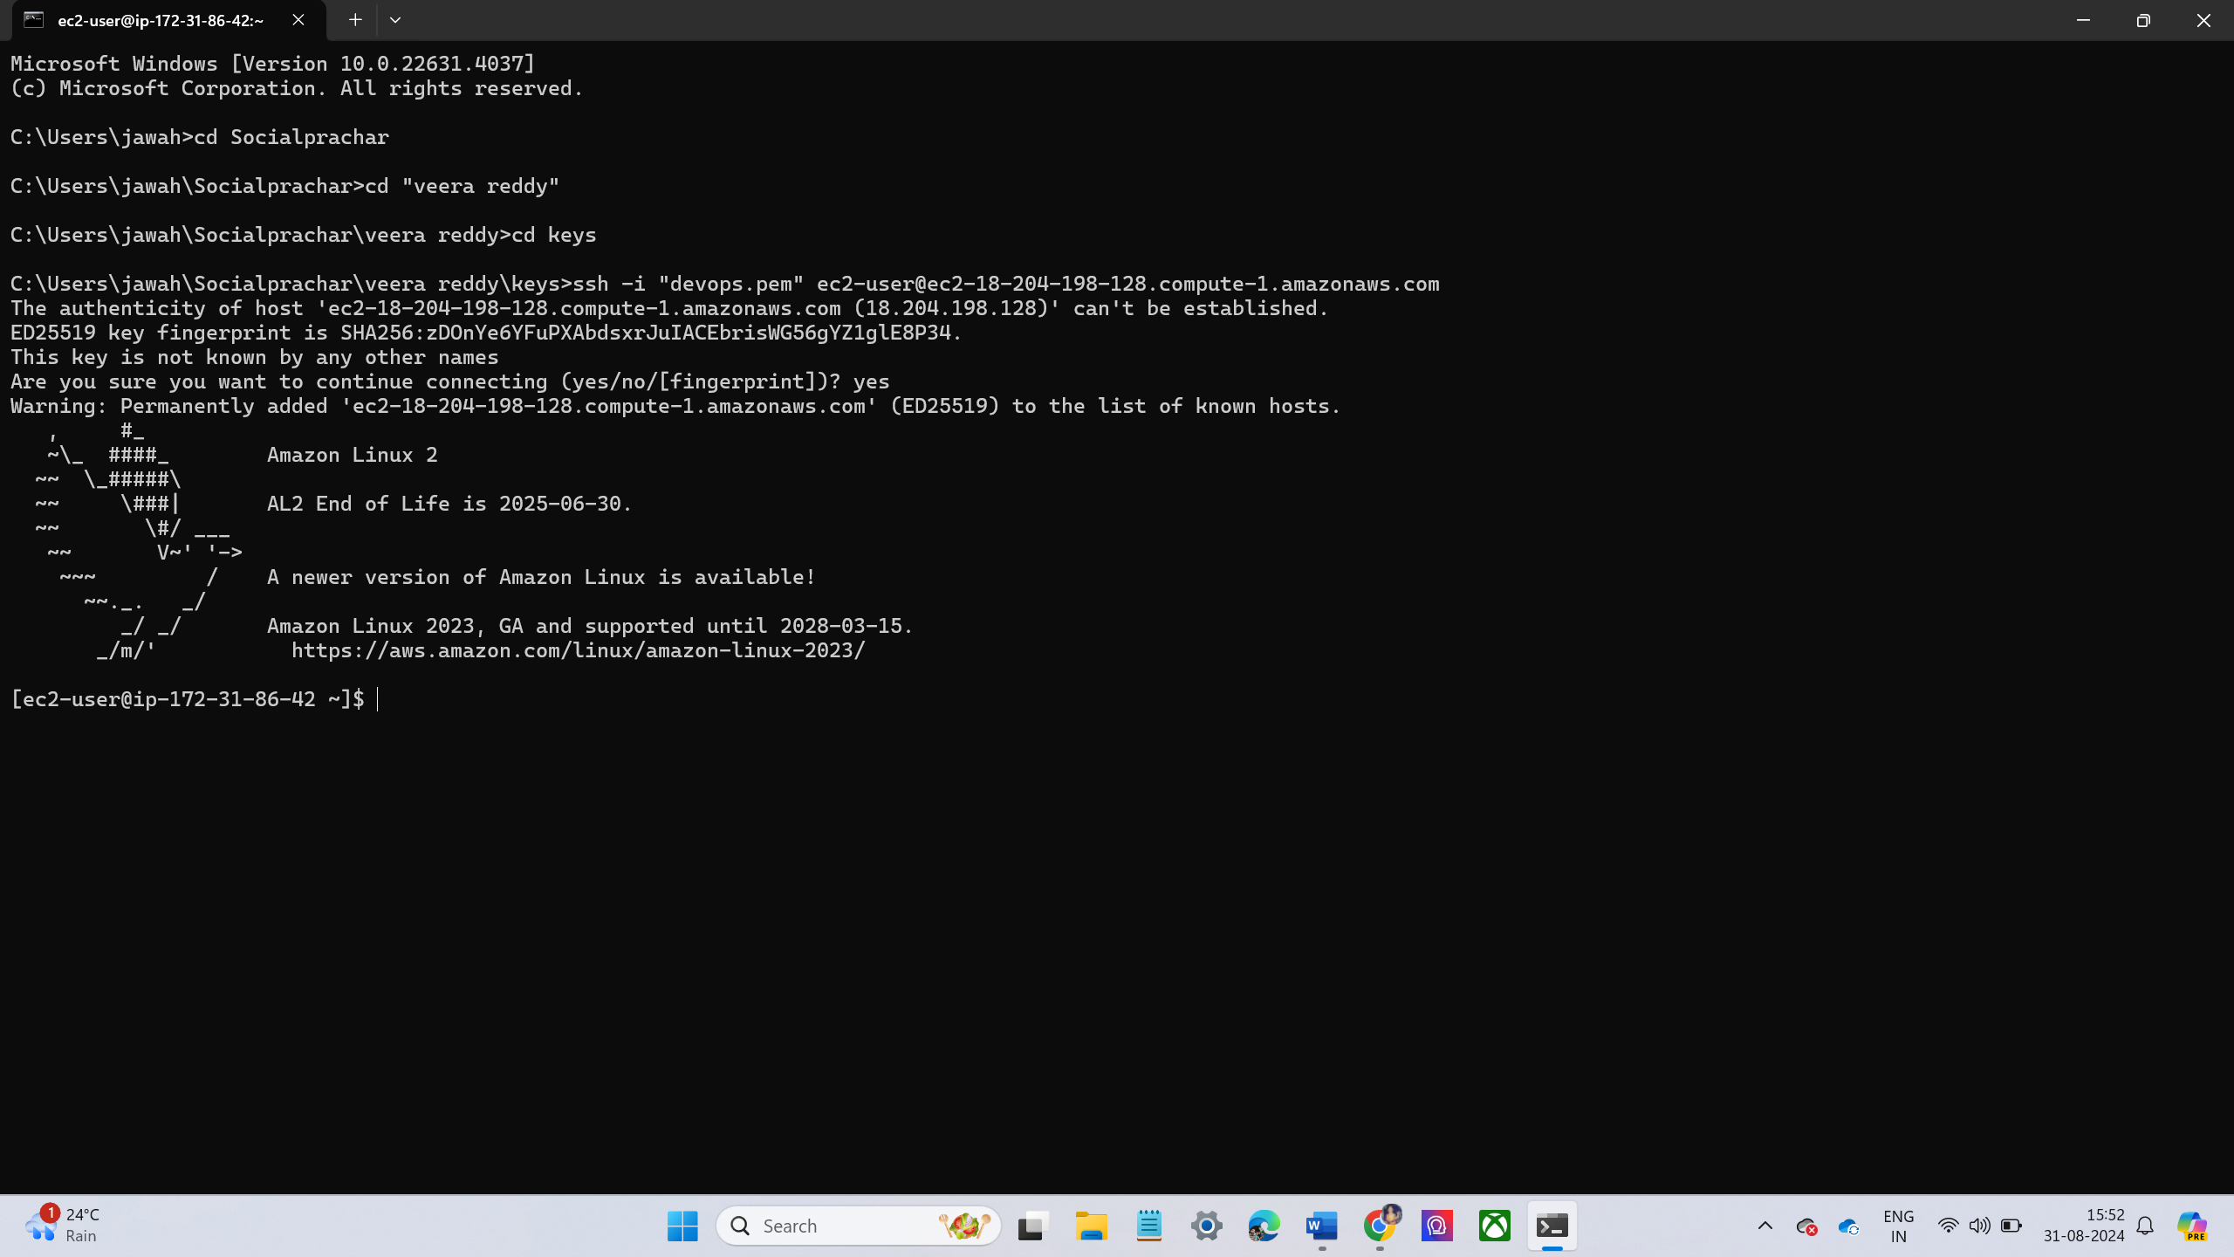

* Run the following command to check if the volume is attached
  + Lsblk

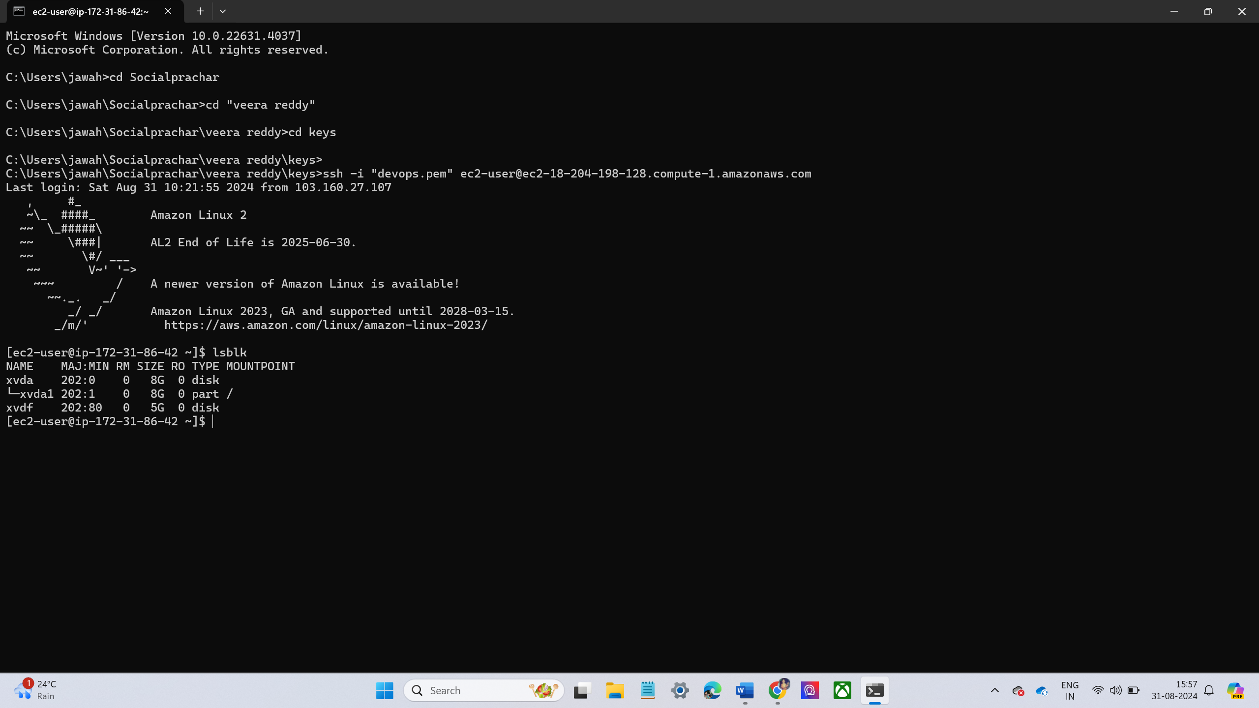

* Create a mount point
* Mount the new volume
* Verify the volume is mounted

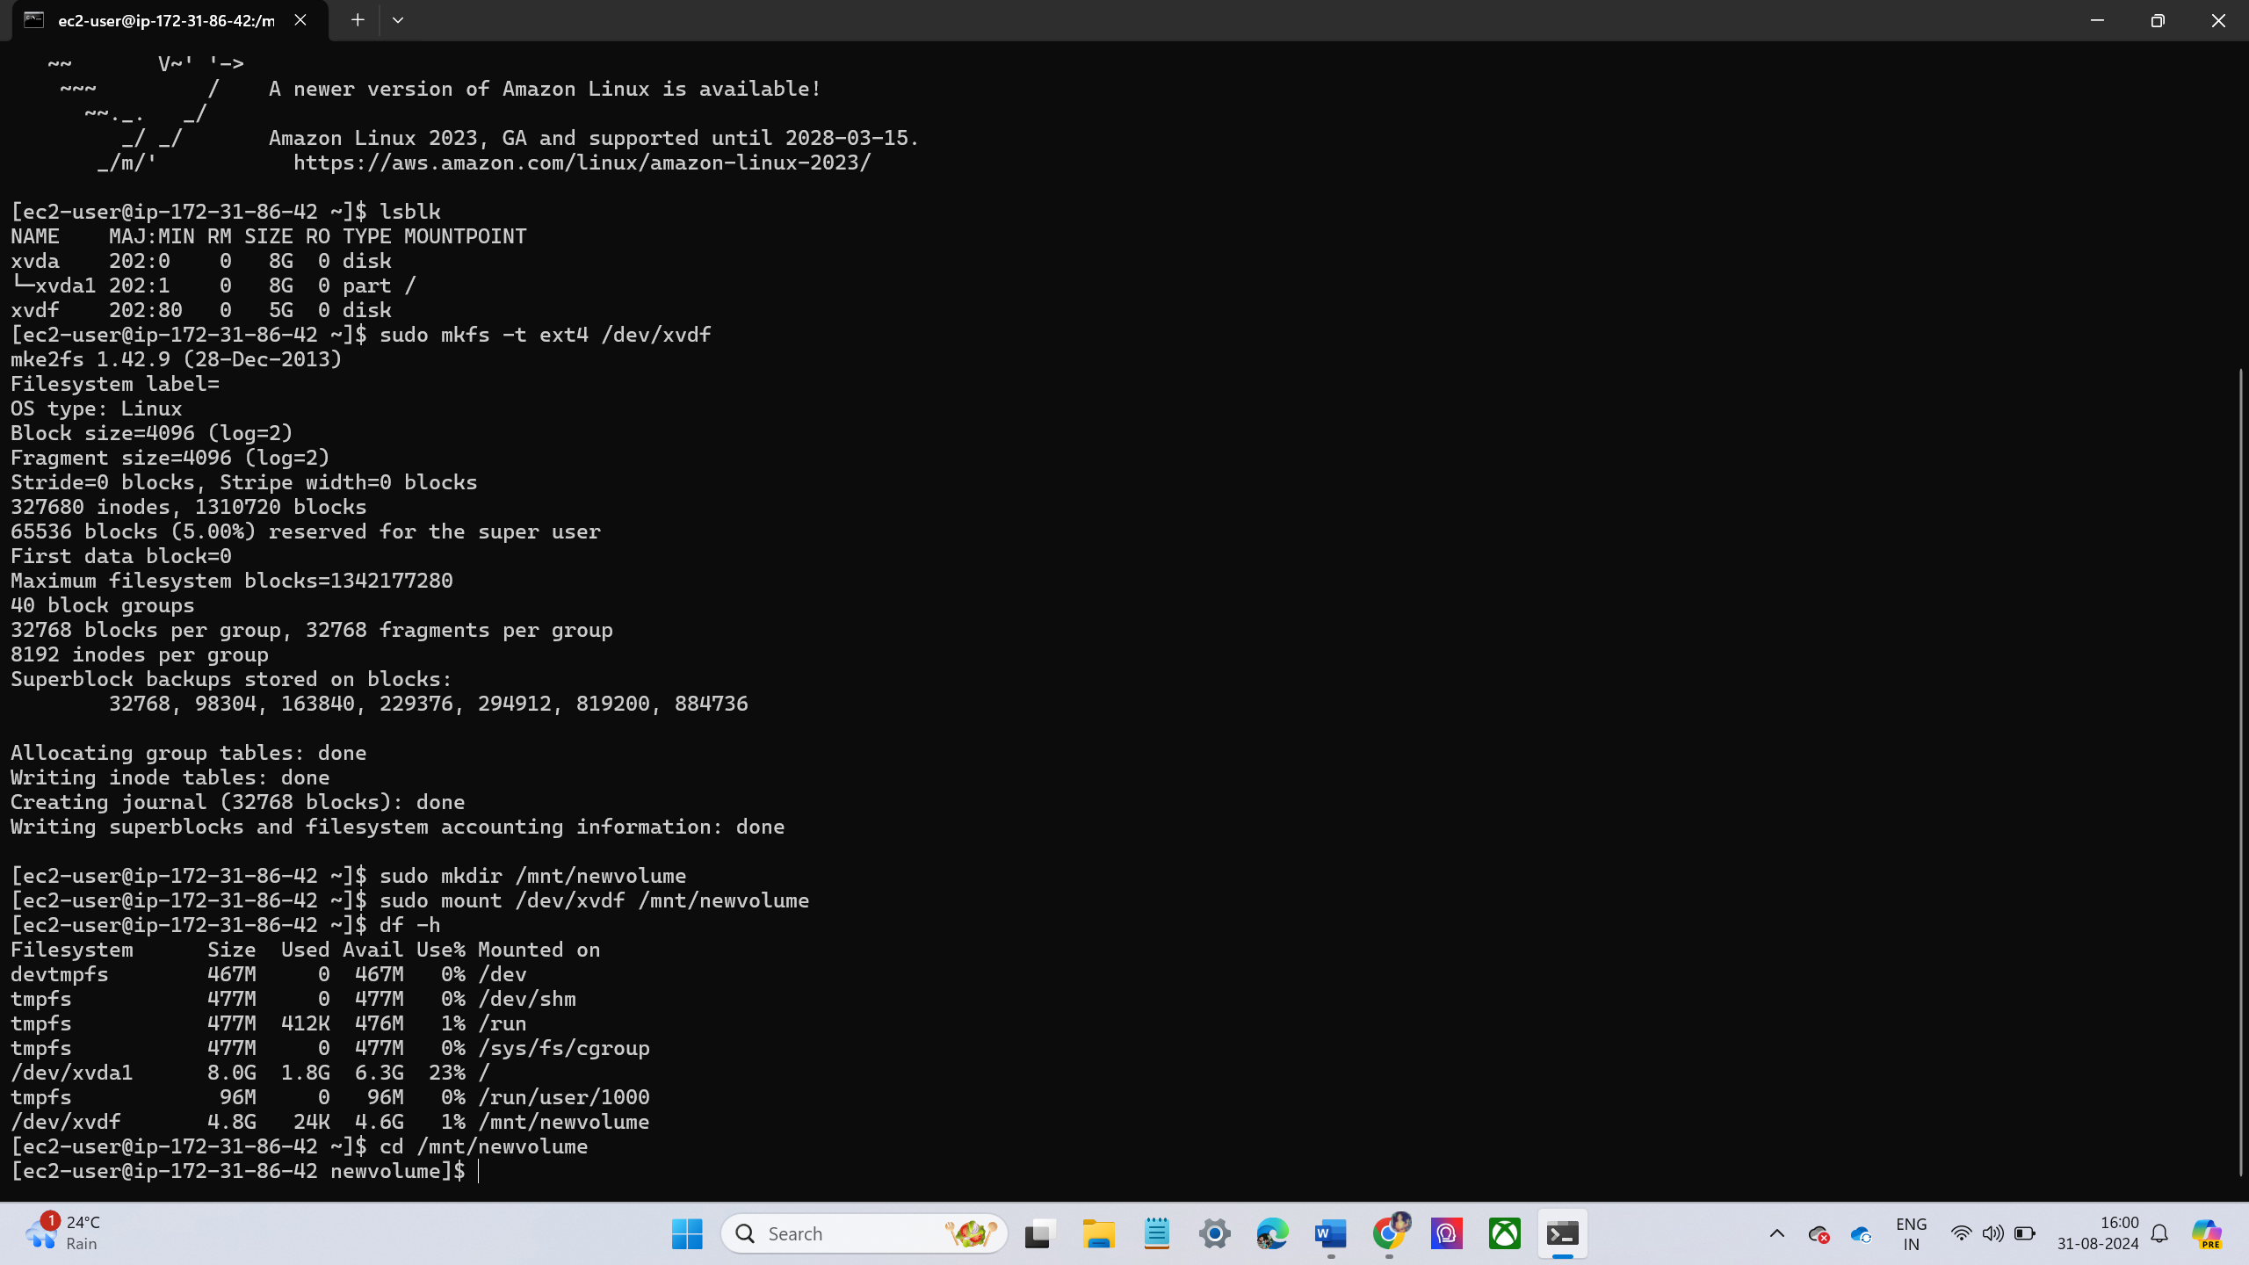

* Put Some Data in the Volume
* Go to the Mount directory.
* Create a some text files using touch command.
* When I am creating files in first time I didn’t use sudo. They show an error be permission denied
* Then after I use sudo it was created.

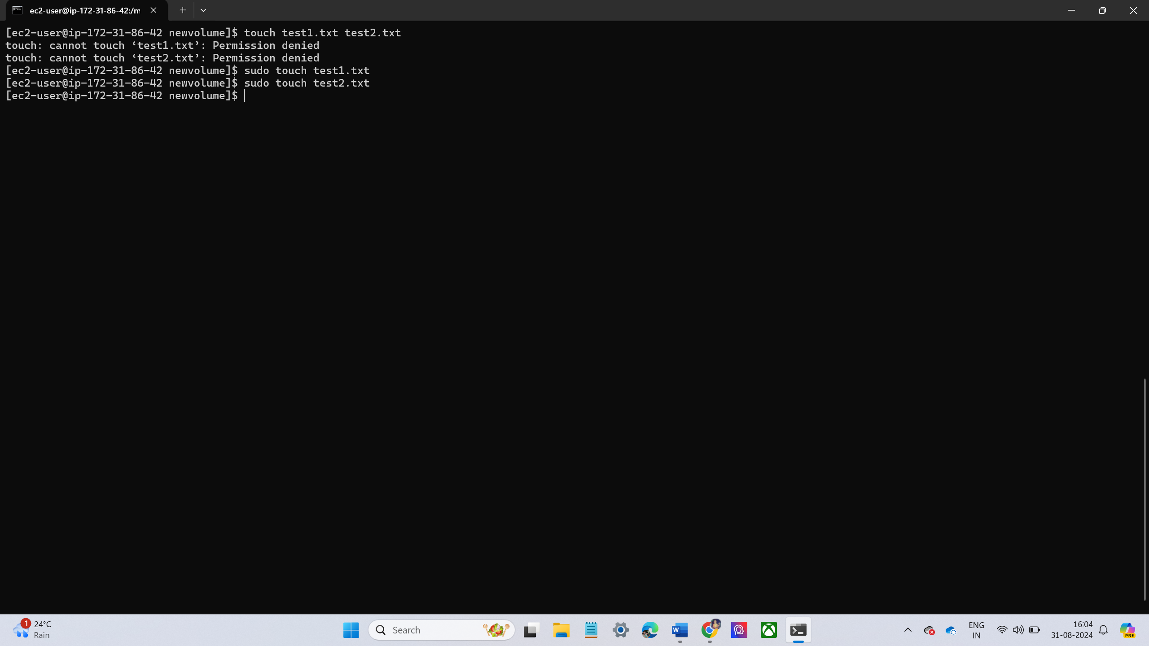

* Now add some content to the file
* Increase the Size of the Volume to 8GB.
* Select the volume created (5 GiB) and click **Actions** → **Modify Volume**.
* Change the size to **8 GiB** and click **Modify**.

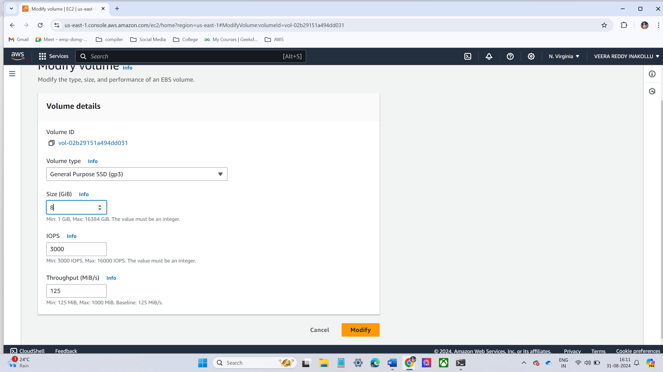

* Inside the EC2 instance, run the following command to ensure the volume size is updated:lsblk

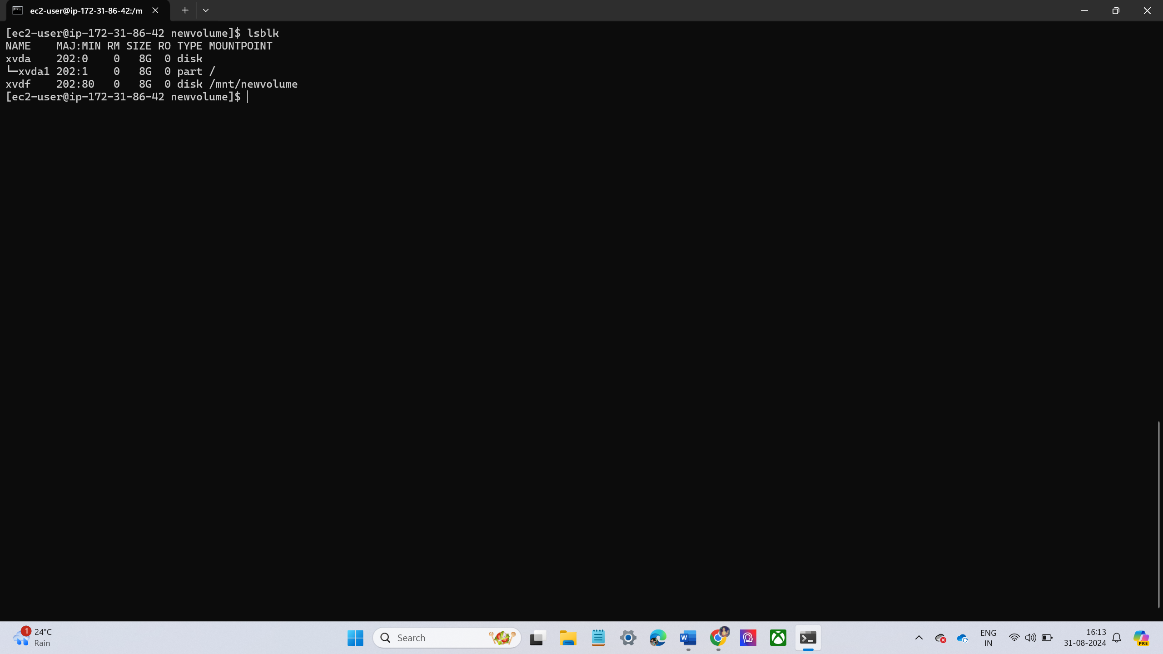

* Extend the Size of the Volume Inside the Linux Machine
* Extend the file system to use the full 8GB: sudo resize2fs /dev/xvdf

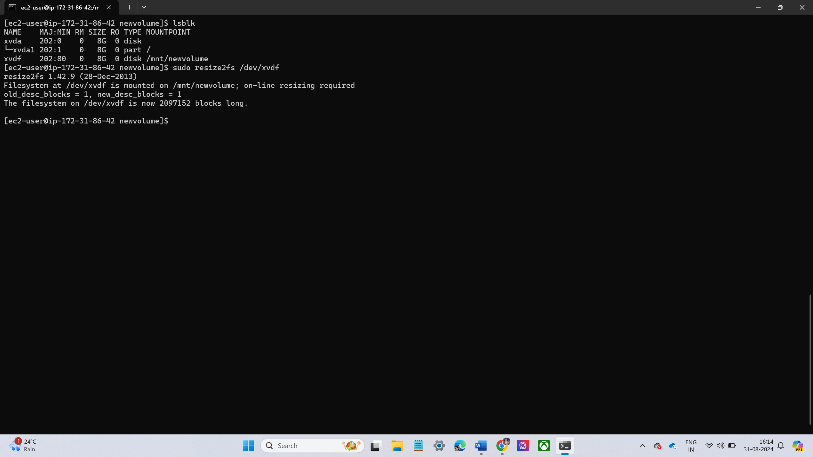

* Take a Screenshot of the Volume and Delete It

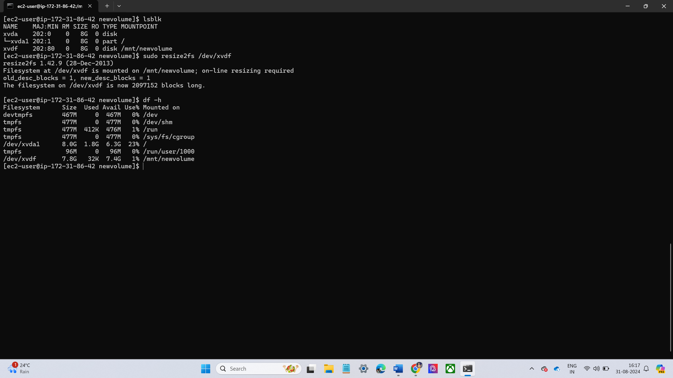

* Create a New Volume with the Snapshot and Attach It to the Server

